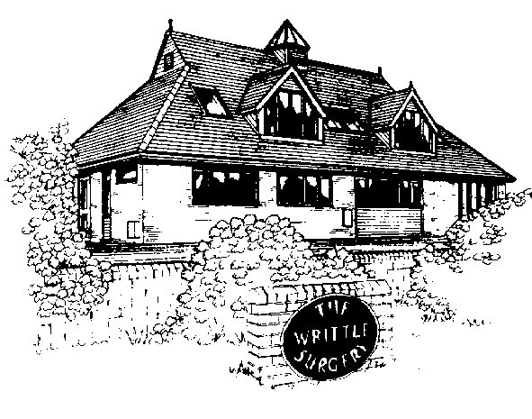

The Writtle Surgery

Patient Participation Group Report 2011/12

The Writtle Surgery
16a Lordship Road
Writtle
Chelmsford
CM1 3EH

Dr Bailey, Dr Wood, Dr Vincent and Dr Wilson

The Writtle Surgery
Patient Participation Group Report 2011/12

The Patient Participation Group at The Writtle Surgery was set up in late October2011, to understand the views of patients on the services that the Writtle surgery offers, it is also a way of involving patients in shaping the future of Primary Health Care. The group plans to meet periodically to discuss any improvements that could of might be made to improve our service. We review several parameter including local health needs, services in the community and the effect of NHS changes on the practice. Between meetings the group keep in touch and communicate using email so that we are all kept up to date with the implementation of changes both at Practice Level and the new NHS reform.

This Report includes
- A description of the profile members of the PPG
- The steps we have taken to ensure PPG is representative and the steps we took to try and engage with a cross-section of patients
- Our patient survey
- An action plan for the PPG
- Confirmation of our action plan
- How the PPG plans to progress to achieve further in 2012/13
- Practice profile and confirmation of our opening times

Introduction

In 2011 the government launched a new ‘direct enhanced service’ (DES) for Patient Participation Groups (PPGs). The aim of this direct enhanced service was to encourage dialogue and involvement between GP practice and their patients.

This report is intended to be read by all patients, PPG members, members of the local community and the PCT.

The Writtle Surgery Practice Information

Practice Profile

Our Practice population is almost 7,900 of which a quarter are over 65 years. It is centred on Writtle village with a population of nearly 5,500. Within the Practice area there are two sizeable villages of Roxwell and Good Easter, plus the hamlets of Highwood, Cooksmill Green, Chignal St James and about half of Willingale. The Practice is semi-rural with high quality farmland (mainly arable) and includes nearby Hylands Park.

Many of our patients work in Chelmsford, Brentwood or commute to London. A quarter of our patients are defined as rural. This applies to sparsely settled areas of agricultural countryside and includes those patients living more than 3 miles from the surgery. Historically we carry out a higher proportion of home visits than an urban Practice because of inadequate public transport. The village has three Showman (fairground) sites and there is a 16 pitch ECC Traveller site just beyond the village boundary.

Adjacent to the surgery is Writtle College, part of Essex University. The student population has recently increased significantly and presents its own challenges for the Practice to handle. Students are drawn from the UK and abroad, including Africa, mainland China and Japan.

Within the Practice area there is one sheltered housing unit of flats and bungalows and a Springboard Housing Trust of 34 warden controlled flats.

Profile of practice population
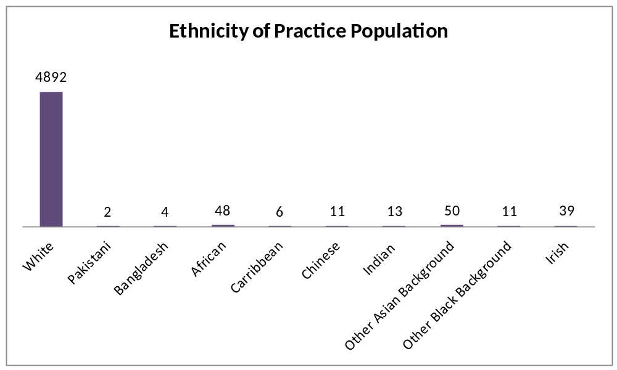

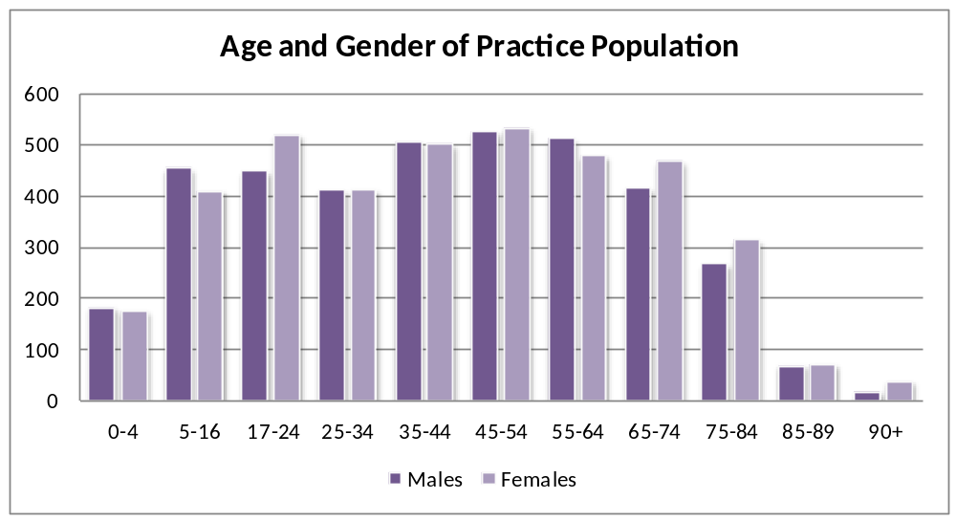

Opening times and Extended Hours

The practice is open from 08:00 to 18:30 Monday to Friday. We do not close at lunchtime. Access to services we provide are through the telephone and by attending the surgery during surgery hours. 24 hour appointment booking and repeat prescription requests are available online through EMIS Access which is linked to the practice website.

Patients are advised to call at 08:00am for a same day appointment, if they are unable to have a booked appointment then they are added onto the ‘extra list’- there is no limit to the length of this list to ensure all patients are seen who feel they require a same day appointment.

Our surgery runs a ‘duty doctor’ system; this means that people needing urgent telephone advice or urgent appointments are seen on the same day. Home visits to patients unable to attend surgery take place after morning surgery.

Extended hours surgeries for pre-booked appointments run from 18:30-20:00 on Monday evenings and 7:30-8:00 Friday mornings. Primecare out of hours service covers emergencies outside of contracted surgery hours. By doing ‘todays work today’, we endeavour to minimise use of out of hours (OOH) and A&E.

Appointments

An appointment can be made by either calling reception on 01245 421205, by coming in and speaking to a receptionist, or by booking online through our website www.writtle.gpsurgery.net. In order to access our online appointment booking and repeat prescription ordering service, patients are required to show ID to the reception team who will provide them with a unique user name and password.

Urgent cases will always be seen on the same day. When a patient needs to be seen for a non-urgent problem, they can choose to see their regular doctor and book up to two weeks in advance, or they can choose to see another doctor at a more convenient time if this is preferable. Patients are all registered with the Practice and given a named or “usual” Doctor.

We encourage patients to see their usual Doctor where possible to ensure continuity of care, but recognise there are times when a patient may want to see a particular GP for a particular problem, or need to be seen earlier than his usual GP could see them and we will accommodate these requests. We believe this policy offers improved care for patients with long term conditions.

Staff

The Writtle Surgery currently has four GP partners, one salaried GP and a GP Registrar.

Partners: Dr Bailey, Dr Vincent, Dr Wood, Dr Wilson
Salaried GP: Dr Harrod-Rothwell
GP Registrar: Dr Sodha
Practice Manager: Rachel Maddock

Four Practice Nurses, appointments can be made for,
- Immunisations, cervical smears, HRT, contraceptive pill checks, travel clinic, asthma and COPD reviews, diabetic checks, vascular checks, spirometry, stitch removal, administration of zoladex injections, 24 hour blood pressure monitoring.
Our Healthcare Assistant supports the team by providing
- New patient checks, phlebotomy services, urinalysis, B12 and flu injections, ECGs, blood pressure monitoring.
District Nurses and a Community Matron work alongside the team and we are actively involved in developing the EGPC ‘Integrated Care Team’.

Midwife appointments are available two weeks ahead on a Tuesday afternoon.

The Macmillan Nurse is accessible via Farleigh Hospice, she also meets regularly with our Doctors

On the administrative side, there is a Practice Manager and a team of trained, friendly and helpful administrative and reception staff.

Services

Services provided at The Writtle Surgery include:
- Core GMS work
- Monitoring INR patients
- On-site ECG, phlebotomy, spirometry, 24 hour blood pressure monitoring
- Chronic disease management clinics for asthma, diabetes, COPD, hypertension, vascular disease including coronary artery disease and stroke, chronic kidney disease.
- Minor surgery
- Family planning services including coil.
- Smoking cessation
- Childhood immunisations
- Ear syringing
- Travel clinic
- Health checks including near patient cholesterol testing

The development of The Writtle Surgery PPG

Step 1: To develop a Patient Participation Group

As a Practice we had started to actively engage with the concept of patient participation groups long before they had become an enhanced service.

It is important that we are able to demonstrate strong patient and public engagement and on 17/03/2011 Dr Bailey attended an ‘NHS Mid Essex PCT patient and public forum’. This meeting was an initial meeting to see how the public could engage with the NHS and was a building block for the PPG service. This was led by Dr Donald McGeachy and supported by Dr Bailey.

Dr Bailey also reviewed the practice specific data from the Association of Public Health Observatory website; this showed that Writtle has an older population than the mid Essex mean, with male life expectancy at 80 and females at 86. Is also estimated our ethnicity at 2.6% non-white groups.

A patient was asked to attend our local Essex GP commissioning group meeting to give her views. At the meeting she was able to actively input into discussions about how to improve a patient’s journey from start to finish. This was mentioned in the reception meeting minutes of 17th May 2011 - ‘ patient may also be attending meetings at the surgery to discuss progress’.

But our first step to setting up a working PPG proved problematic.

A review of our Practice demographics supplied to us by our CCG indicated that nearly 30% of our practice population are ‘Successful professionals living in suburban or semi-rural homes’; this would suggest that they are possibly too busy to commit the time required.

The Writtle Surgery started recruitment for the patient participation group late in October 2011.

After an initial discussion with staff about the best way to approach recruitment, taking in to account the guidance, it was decided that we should put notices and posters in the surgery and in the village .

We felt an invaluable way to target patients would be for GPs to discuss it at the end of their appointment, especially with minority populations.

A sign up book was also displayed within the waiting room and at the reception desk next to an advertisement about the PPG. Patients were able to leave their contact details.

For regular visitors to the surgery we also placed an advert in our patient newsletter (appendix 1)

We were concerned that these approaches would be unlikely to reach the largest proportion of our population. We considered that a good way of widening the target group would be via our website, which people can utilise to book appointments and more regularly to order prescriptions.

We placed a PPG advert on the website with a link to direct patients to a form whereby they could leave their details for us to contact them.

The PPG sign up facility on the website has not yet had any 30.03.2012‘hits’. (Appendix 2)

We made many attempts to encourage and engage the patient community but unfortunately after all these recruitment drives we still only had 6 interested patients; a very small proportion of our practice population of over 7,500.

We felt it would be important to have a group which represented a wide range of patients both male and female and who also represented the different demographic groups including, for example, travellers and students. We also would look to include members from within minority categories including those with physical disabilities and long term conditions.

Profile of PPG patients
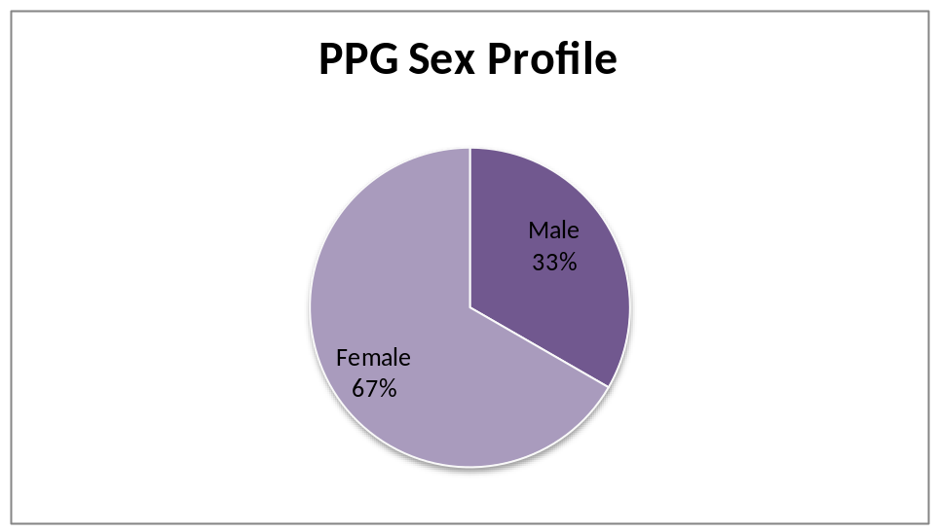
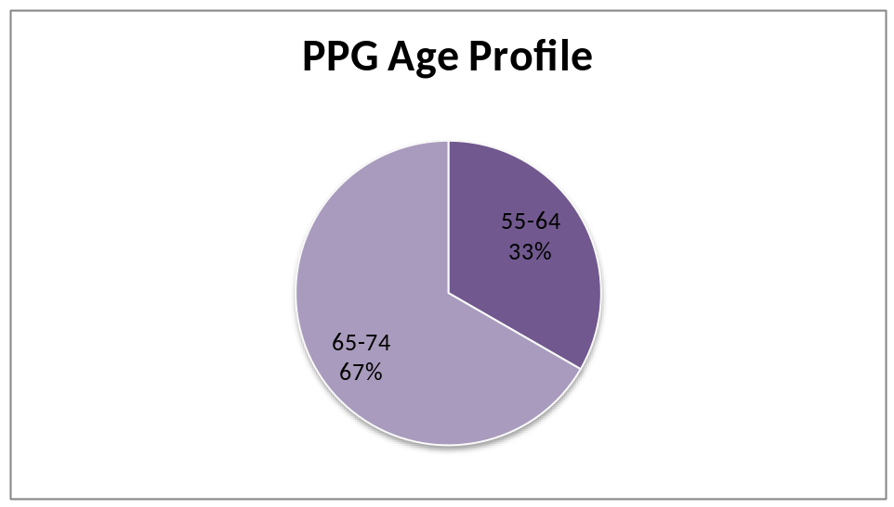

PPG Patient Profile

- Male, aged 72, Caucasian, retired but involved in many different volunteer groups, regular user of surgery.
- Female aged 64 Caucasian, not a regular user of the surgery, two children
- Male aged 67 Caucasian, regular visitor to the GP surgery, registered at practice since birth, retired.
- Female aged 57 Caucasian regular user of the surgery, teacher, three female children
- Female aged 67 Chinese, retired nurse, not very regular user
- Female aged 68 Caucasian regular user of the surgery, one son, retired but involved in many charities.

Initial PPG meeting

For the initial meeting we had 6 patients attend, all the patients at the group are between 55-70 race one is of a minority within our practice demographic.

The first meeting was held at the Writtle Surgery on March 26th 2012 at 7pm. Please see the agenda attached (appendix 3)

In attendance were Anne Young - Practice Manager Writtle Surgery, Dr Bailey, Dr Vincent and Dr Wood together with the six patients.

Prior to the meeting, it was decided that at least one partner would always attend the PPG meeting as would the Practice Manager.

Please see the minutes attached (appendix 4)

The meeting was very positive. It was agreed that our PPG would be called WPG (Writtle Patient Group).

It was decided that a basic development plan for 2012/13 would be agreed and would evolve and change as the group grew. The first point to achieve was ‘to set up an email group within the surgery catchment area’ the target date for this was July 2012 and was to be discussed at the next meeting.

The group also agreed on the ‘aims and objectives of the group’ (appendix 5)

As this was the initial meeting the main topic of discussion was the recruitment drive that would need to take place to ensure we would have a representative from all demographic groups. The PPG decided that they would make contact with the schools (PTA), Writtle College, Scouts and Guides.

Within our practice population there are hard to reach groups, for example patients in sheltered housing and travellers. It was decided that as the WPG starts to grow we would approach these groups, but this would have to be handled sensitively. To encourage engagement, Dr Bailey has offered to invite a personal friend, who is a settled traveller, to attend a PPG meeting, if the group feel that would be help improve understanding of this particular group. Previously she has attended a meetings at NHS Mid Essex PCT to discuss ways of improving dialogue and engagement with this hard to reach group. We hope that the speaker will encourage and motivate the members.

The concept of a ‘virtual group’ was also discussed but would be followed up in the next meeting. This would help to engage with people who are unable to make the time commitments to attend a meeting but who wish to be involved with the surgery. The group discussed the terms for the patient group (appendix 6)

The group also agreed to become affiliated with the National Association for Patient Participation. This will be funded for the first year by Writtle Surgery.

It was also suggested that someone would visit another established PPG to share ideas.

The Patient Survey results have been received by the PPG, they were discussed and 2 members have taken copies.

Although we were unable to carry out a local practice survey before the first meeting due to earlier recruitment problems, we were able to discuss the Patient Dynamics survey March 2012 which had been carried out directly with patients in the practice population, detailed below.

Patient Dynamics Survey

We sought to obtain the views of registered patients by way of a Patient dynamics GPAQ survey.

Sample and Methodology
A kit comprising of, the desired amount of questionnaires and instructions were posted to the practice, along with five pens and two posters.

The questionnaires were numbered and matched to the practice or individual doctors. The questionnaires were offered to each patient to be completed in the surgery. We then send the completed ones for analysis.

Discussions
The patient dynamics survey was discussed at the first WPG meeting, this would form the basis for our next meeting when we will discuss how we plan to carry out a local practice survey.

Results
An example of some of the questions and their ratings are shown in appendix 7.

Please see below for a selection of the survey responses which we felt were most relevant to discuss,
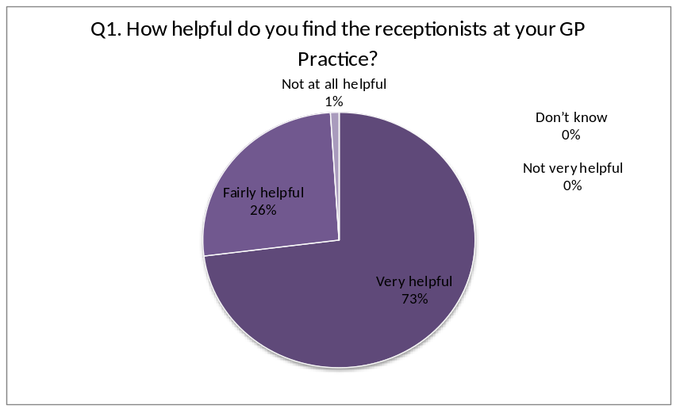

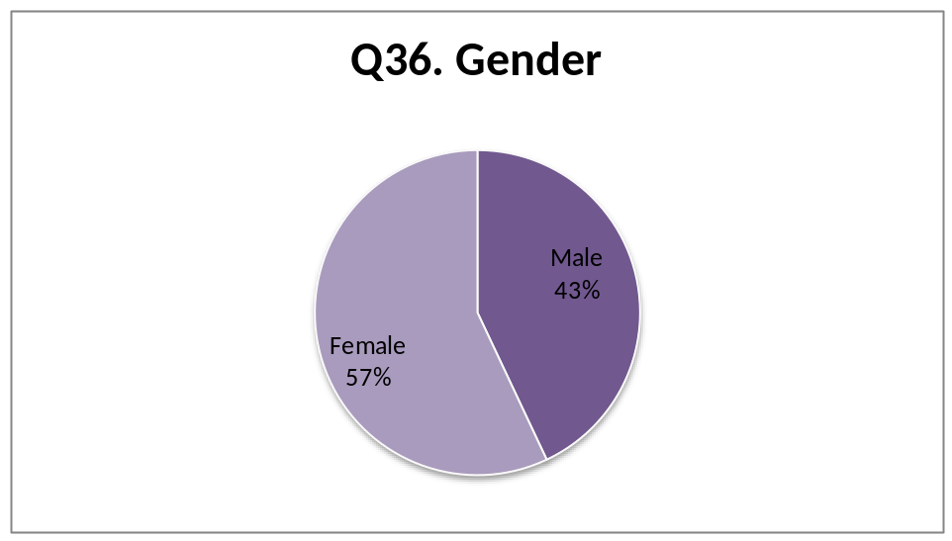

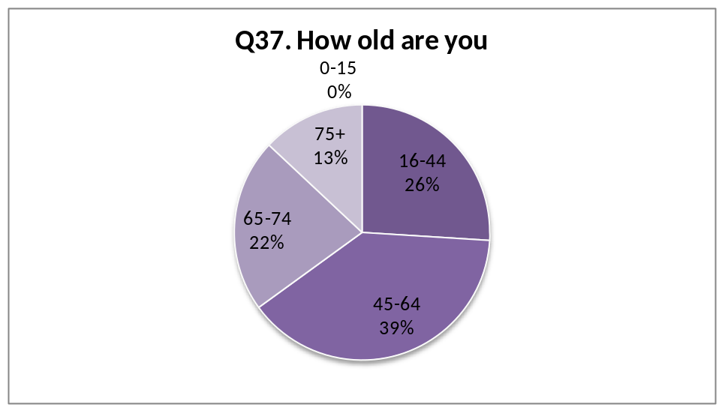

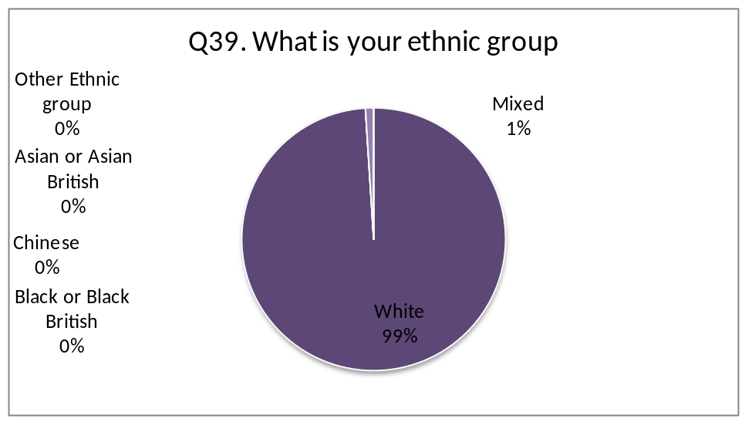

99% of patients who filled in the survey are ‘white’ and only 1% are ‘mixed’, this suggeststhat we do need to target more patients within our area.

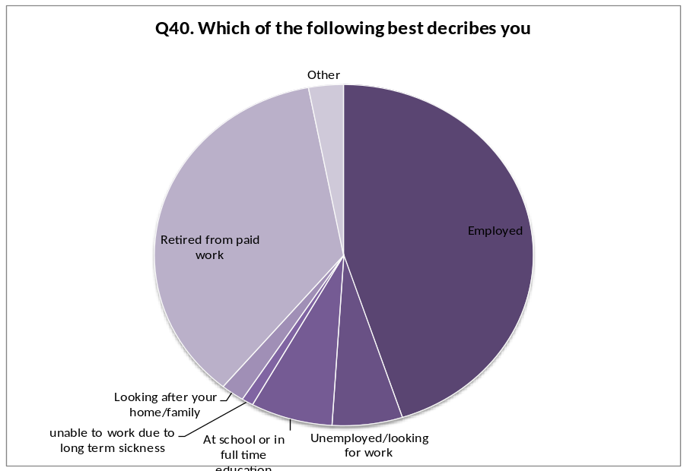

45% of the responses were from people employed and 36% retired. The response figures were very low from ‘looking after you home/family, unemployed/looking for work and at school or full time education’

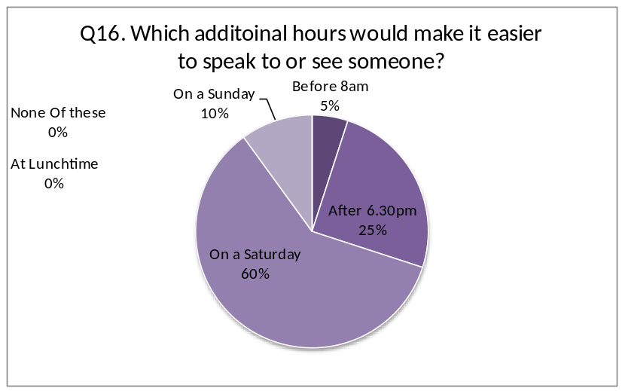

Patients were also given the chance at the end of the survey to write in their own comments, a number of people commented that the reception staff could be more friendly, parking issues were raised, and for Saturday morning access.

A selection of the positive comments people made:

- ‘I have always received excellent service from my practice’
- ‘An excellent GP surgery. Pleasant to visit’
- ‘I find all staff at the practice very helpful and polite’
- ‘I love my practice’

Overall patients were very complimentary about the surgery and the service we provide.

We were pleased with the outcome of the survey as it gives us areas to investigate for possible improvement, a selection of those comments are as follows

- ‘ it would be useful to have at least one doctor in the surgery on a Saturdays’
- ‘could do with better parking spaces’
- ‘only that a Saturday morning surgery would be useful’
- ‘appointments in the afternoon are impossible’

One area of concern raised in the Patient Survey has been the ease of getting through to the surgery on the telephone. This is an area where we shall be looking to the PPG for ideas for improving this area of Surgery performance. We are also going to conduct research in line with the new 2012/13 QoF achievement to improve access to our surgery.

At the end of the meeting the opportunity was given to agree and discuss a short action plan.

The next meeting is scheduled for May 10th 2012

Conclusion

We are excited to watch how our patient participation group grows and progress.

We hope that through more advertisement we can attract more members who will ultimately have the chance to actively engage with the surgery.

The following two pages include the action plan for the group and the action plan generated from the survey. This will form the basis to move into the second stage of the DES in 2012/13.
Area to Be addressed | Action | By Whom | By When | Completed?
Agree Aims | WPG to jointly agree aims of the group | WPG | 10/05/2012
Join NAPP | Practice Manager to join NAPP | WPG/Surgery | 10/05/2012
Practice staff to act as WPG admin | PM to speak to admin staff | PM | 10/05/2012
General recruitment in rural areas | Posters, visiting, word of mouth | WPG | 10/05/2012
Recruitment schools/colleges | Visiting and governors meeting | BB | 10/05/2012
Playgroups | Visiting and speaking to parents | MP | 10/05/2012
Action plan for WPG
Action Plan for Surgery in regard to results from Patient survey.
Area to be addressed | Action | By Whom | By When | Completed?
Patients would like to see surgery open on Saturday | Publicise the ways we are looking to improve access | PM/Surgery | 10/05/2012/ongoing | Surgery will not open on Saturday, but will publicise ways of access
Patients would like to see improvement in parking | Publicise good practice for car park arrangements | PM/Surgery | 10/05/2012/ongoing
Improve responses from different groups of people | Publicise the WPG | PM/Surgery | 10/05/2012
Improve telephone access | Investigate | PM/WPG | 01/09/2012
Improve appointment system | investigate | PM/WPG | 01/09/2012
We will investigate all the above findings and proposals which have arisen from the practice survey and at the next meeting we will then be able to discuss with the WPG whether they can be implements and the reasons why any findings or proposals should not be implemented.
Appendix 1
Newsletter was displayed in reception from February 2012, patients are able to read this in the waiting room and also take a copy home.

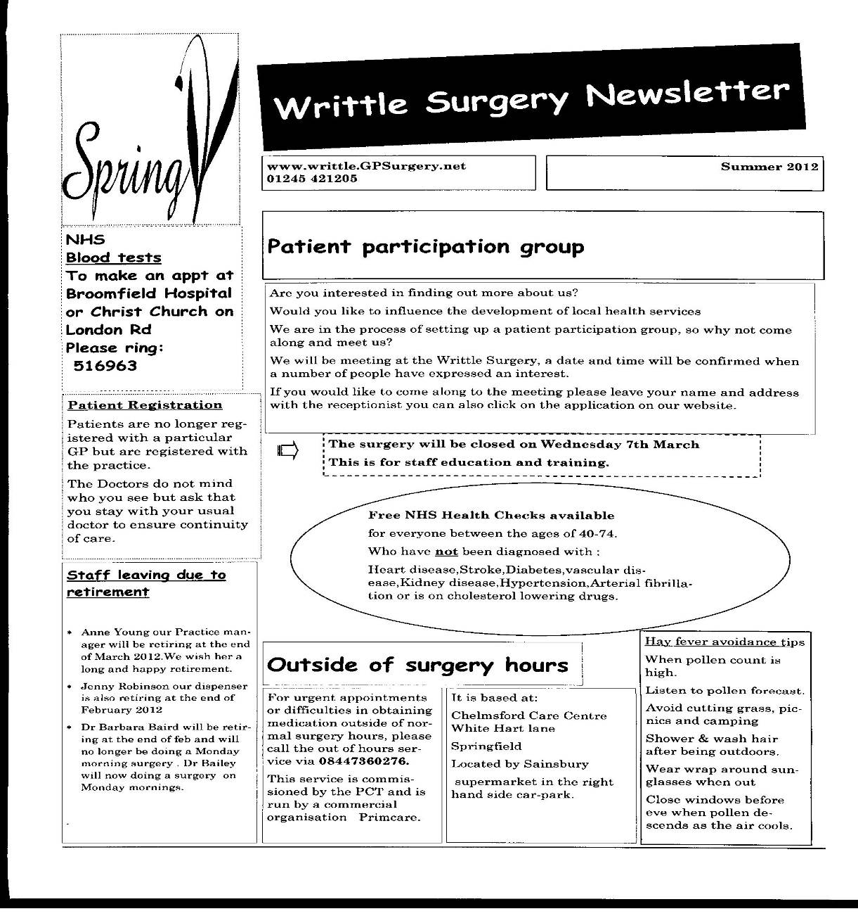
Appendix 2

This was posted on the website in October 2011.
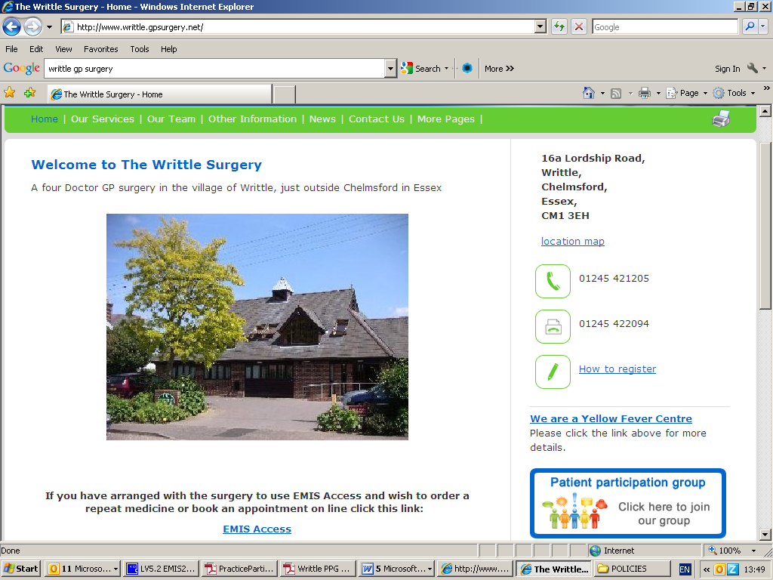
Appendix 3
Writtle Patients Participation Group

Agenda for preliminary meeting, March 26, 2012 Writtle Surgery 7pm

- Welcome and introductions

- Aims and objectives

- Function of the PPG

- Ground rules

- Expanding representation

- Next steps

- AOB

- Next meeting

Action points -
Appendix 4
Practice notes of the Writtle Patient Participation Group (WPG)

Monday 26th March 1pm at the Writtle Surgery

Present SR, AR, BB, ML, SW,MP

From the surgery – GPs - Dr Vincent, Dr Wood, Dr Bailey, Anne Young (Manager)

- Need to agree terms
- Join National Association for Patient Participation

Aims

- To promote actions for both staff and Patients alike
- Membership open to all registered patients, need to recruit more onto group

Activities

Writtle news for newsletters.
Ensure patient grumbles don’t come in.

Meetings

Agreed to have one GP and the Practice Manager to the meetings.
Notice of meetings by emails and Writtle news.

Where to meet
At present the surgery. Can use waiting room if group expands as long as the meeting is not on Monday at 7pm as the surgery is still open seeing patients for the late Surgery.

Admin Staff

Secretary and Practice Administrator will be asked if they are happy to do this.

Function of group

- Expanding registration – Writtle news goes to every household
Village website
PTA at schools
College
Church
The group may have to meet next month if the group expands
Practice area was discussed, need rural representation.

Plans
Go into schools, College, travellers later, Scouts, Girl Guides, Toddler group.
BB will do schools, MP will do Playgroups.
Virtual at next stage

Next Steps
- Recruitment drive
- 1st contact for the Surgery is The Practice Manager
- Stuart to tidy up terms for WPG

Date of next Meeting May 10th 7pm at the surgery
Appendix 5

Writtle Patients’ Group - WPG
Aims and Objectives
1. Title The group will be called Writtle Patients’ Group (WPG) and will be affiliated to the National Association for Patient Participation.
2. Aims The aims of WPG are to strengthen the relationship between patients and the practice, give patients a voice in the organisation of their care and contribute to the development of services.
3. Membership of WPG will be open and free to all registered patients and staff of the practice.
4. Objectives 4.1 WPG will be kept informed of the practice policies relating to the PCT or equivalent organisation, to which it belongs. It may express opinions on these policies on behalf of the patients.
4.2 WPG will consult with the practice on service development and provision and assist in the assessment of community medical needs.
4.3 WPG will contribute to, and be kept informed of, practice decisions.
4.4 WPG will advise the practice on the education needs of the community by encouraging and supporting activities within the practice to promote preventive medicine and healthy lifestyle choices.
4.5 WPG will produce a newsletter three times a year informing patients of the work of the practice and activities of WPG. The newsletter will be distributed by email and through the post where necessary, and will be made available in the surgery and on the WPG web page.
4.6 WPG will seek to ensure that patient information and advice are readily available and clearly presented.
4.7 WPG will represent patients at the practice in seeking to influence local provision of health and social care.
5. Meetings 5.1 WPG will endeavour to meet no fewer than four times a year, and will, in addition, normally hold an annual meeting in March each year.
5.2 Notices of meetings, reports on meetings and information about WPG’s activities will be displayed on WPG notice boards, in surgery waiting rooms and on WPG’s web page and members will be notified by email alerts, and through the post when necessary.
6. Structure 6.1 WPG’s activities will be organised by an executive team of volunteers and invited members.
6.2 The executive team will comprise: a Chair, Deputy Chair, Secretary and Treasurer, and between 10 and 15 members, to be agreed at the annual meeting. Other members will be co-opted as required.
6.3 An email subsidiary group consisting of eligible patients will be set up to contribute to the consultation process
6.4 The point of contact between the practice and the WPG will be the Practice Manager.
6.5 Administrative assistance will be provided by staff at the practice
Appendix 6

Terms for Writtle Patient(s) Group

1. Title of the Group The Group shall be called Writtle Patient Group (WPG) and shall be affiliated to the National Association for Patient Participation.
2. Aims of the Group The aims of the Group are to promote co-operation between the practice and patients to the benefit of both
3. Membership of the Group Membership of the Group shall be open and free to all registered Patients and staff of the Practice.
4. Activities of the Group
4.1 The Group will be kept informed of the Practice policies relating to the PCT to which it belongs. It may express opinions on these policies on behalf of the patients.
4.2 The Group will consult with the Practice on service development and provision and assist in the assessment of community medical needs.
4.3 The Group will contribute to, and be kept informed of, Practice decisions.
4.4 The Group will advise the Practice on the education needs of the community by encouraging and supporting activities within the Practice to promote preventive medicine and healthy lifestyle choices.
4.5 The Group will produce a Newsletter three times a year informing Patients of the work of the Practice and activities of the Group. The Newsletter will be distributed by email and through the post where necessary, and will be made available in the surgery and on the PPG web page.
4.6 The Group will seek to ensure that Patient information and advice are readily available and clearly presented.
4.7 The Group will represent patients at the Practice in seeking to influence local provision of health and social care.
5. Meetings of the Group
5.1 The Group will endeavour to meet no fewer than four times a year, and will, in addition, normally hold an Annual General Meeting in February each year.
5.2 Notices of meetings, reports on meetings and information about the PPG’s activities will be displayed on PPG notice boards, in surgery waiting rooms and on the Group’s web page, and members will be notified by email alerts, and through the post when necessary.
6. Organisation of the Group
6.1 The Group’s activities will be organised by a Committee of volunteers and invited members.
6.2 The Committee will be composed of a Chair, Deputy Chair, Secretary and Treasurer, and between four and six members, to be agreed at the AGM. Other members will be co-opted as required.
6.3 Administrative assistance will be provided by staff at the Practice.
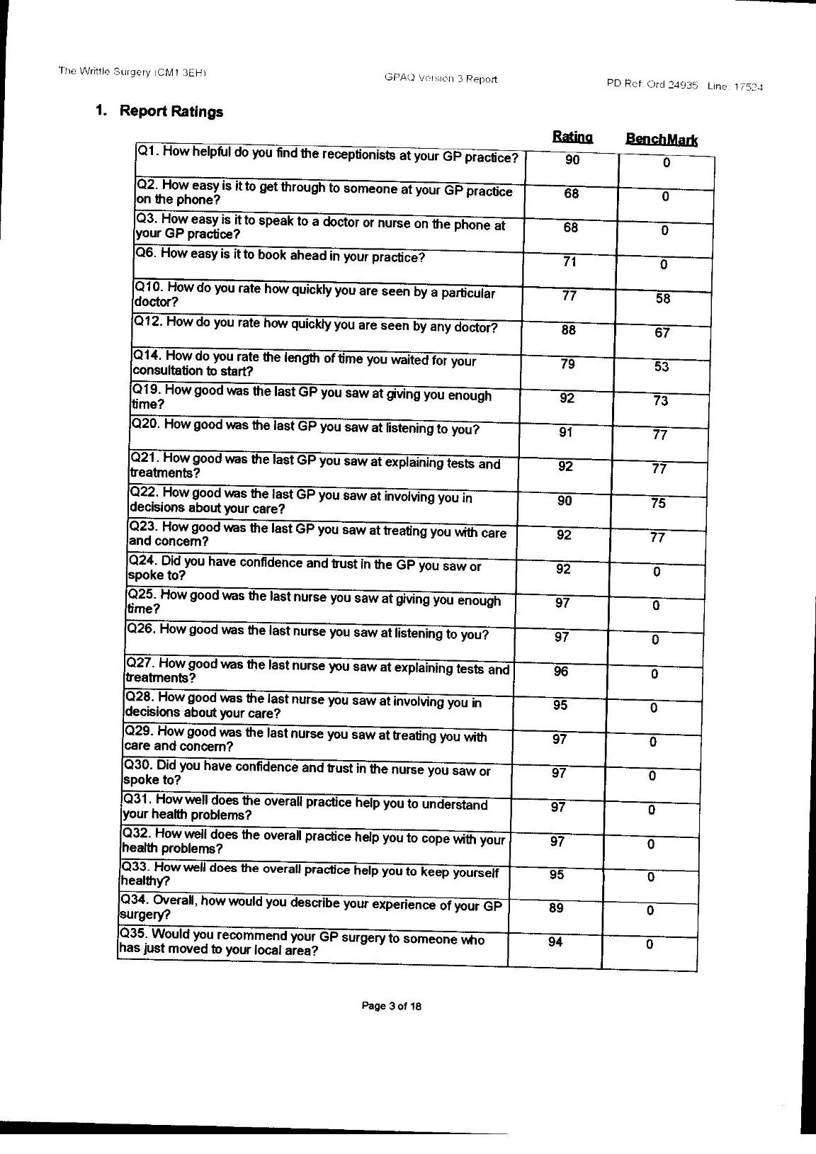
Appendix 7
GPAQ REPORT

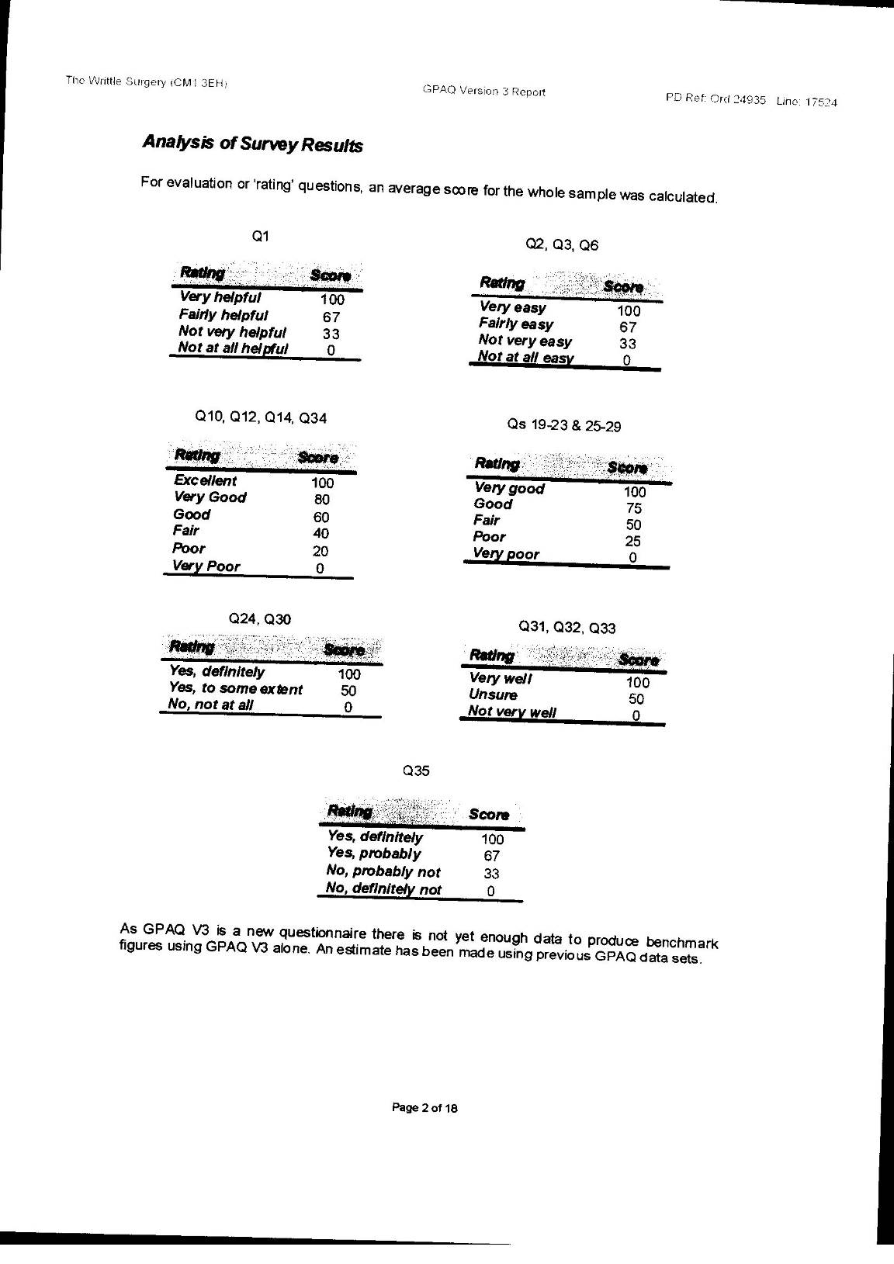
Appendix 8
GPAQ Report

