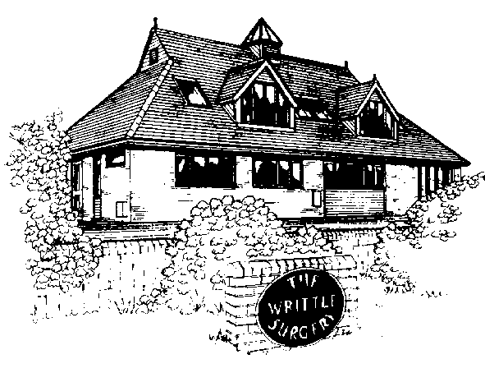

The Writtle Surgery

Patient Participation Group Report
2012/2013

The Writtle Surgery
16a Lordship Road
Writtle
Chelmsford
CM1 3EH

Dr Bailey, Dr Wood, Dr Vincent and Dr Wilson

The Writtle Surgery
Patient Participation Group Report 2012/2013

The Patient Participation Group at The Writtle Surgery was set up in late October2011, to understand the views of patients on the services that the Writtle surgery offers, it is also a way of involving patients in shaping the future of Primary Health Care. The group has met periodically to discuss any improvements that could be made to improve our services. The patient group has already helped shape changes within our practice and will also be consulted when we change our appointment system later this year. Between meetings the group keep in touch and communicate using email so that we are all kept up to date with the implementation of NHS changes both at Practice Level and national level.

This Report includes

- Practice Profile
- PPG group profile
- Patient questionnaire
- Action plan and survey results
- Patient comments on survey
- Agendas of PPG meetings

Introduction

In 2011 the government launched a new ‘direct enhanced service’ (DES) for Patient Participation Groups (PPGs). The aim of this direct enhanced service was to encourage dialogue and involvement between GP practice and their patients.

This report is intended to be read by all patients, PPG members, members of the local community and the PCT.

The Writtle Surgery Practice Information

Practice Profile

Our Practice population is almost 7,900 of which a quarter are over 65 years. It is centred on Writtle village with a population of nearly 5,500. Within the Practice area there are two sizeable villages of Roxwell and Good Easter, plus the hamlets of Highwood, Cooksmill Green, Chignal St James and about half of Willingale. The Practice is semi-rural with high quality farmland (mainly arable) and includes nearby Hylands Park.

Many of our patients work in Chelmsford, Brentwood or commute to London. A quarter of our patients are defined as rural. This applies to sparsely settled areas of agricultural countryside and includes those patients living more than 3 miles from the surgery. Historically we carry out a higher proportion of home visits than an urban Practice because of inadequate public transport. The village has three Showman (fairground) sites and there is a 16 pitch ECC Traveller site just beyond the village boundary.

Adjacent to the surgery is Writtle College, part of Essex University. The student population has recently increased significantly and presents its own challenges for the Practice to handle. Students are drawn from the UK and abroad, including Africa, mainland China and Japan.

Within the Practice area there is one sheltered housing unit of flats and bungalows and a Springboard Housing Trust of 34 warden controlled flats.

A ) Group Profile

Face to face group

4 female and 2 male.
- Male, aged 72, Caucasian, retired but involved in many different volunteer groups, regular user of surgery.
- Female aged 64 Caucasian, not a regular user of the surgery, two children
- Male aged 67 Caucasian, regular visitor to the GP surgery, registered at practice since birth, retired.
- Female aged 57 Caucasian regular user of the surgery, teacher, three female children
- Female aged 67 Chinese, retired nurse, not very regular user
- Female aged 68 Caucasian regular user of the surgery, one son, retired but involved in many charities.

Virtual Group
- The group are yet to implement a virtual group; this is an aim for them. They will also link with the Writtle Village website.

B) Establishing a PPG

We felt it would be important to have a group which represented a wide range of patients both male and female and who also represented the different demographic groups including, for example, travellers and students. We also would look to include members from within minority categories including those with physical disabilities and long term conditions.

We have taken steps throughout the year to recruit new members including

- Writtle surgery newsletter
- Posters in the waiting room
- Advertising on website
- Poster in local library and parish notice board
- Sign up sheets (shown below)
- Patients approached directly by GPs and Nurses
- Publication in Writtle parish magazine (as shown below)

Publication in Parish News

Writtle Patients’ Group

A new group has been launched in Writtle to give patients a voice in their health care at the village doctors’ surgery.

Writtle Patients’ Group aims to be a key link between patients and the surgery and become a forum for feedback and consultation said the group’s chairperson Dianne Collins.

With five GPs, Writtle Surgery has nearly 8,000 patients and as well as the village, covers Roxwell, Highwood and part of west Chelmsford. The patients’ group is led by a team of 14 volunteers and is now setting up an email group to widen consultation among villagers. The group is supported by doctors and staff at the Lordship Road surgery.

Dianne Collins said: “Any patient registered at Writtle Surgery, can become a member of the email group. We want to help the surgery develop its services and for people to take more responsibility for their own health. We’re not, however, a forum for complaints or individual issues.”
Starting an email group, she said, means that it will be easier and quicker for people to be consulted about health issues. Patients can join online at writtle.gpsurgery.net, or complete a form at the surgery’s reception.

She added: “We really want community involvement and to help the GPs and their staff to give patients the best possible care.”

Writtle Surgery practice manager Rachel Maddock said: “This is a fantastic opportunity for the Writtle surgery community to become involved with changes, not only within the surgery but within the ever changing NHS. I would urge anyone who is interested to call into the surgery and leave their details. I am really looking forward to the patient participation within Writtle Surgery.”
After agreement with the surgery, the WPG defined its role to cover the following points:

- WPG will be kept informed of the practice policies relating to the Primary Care Trust/Clinical Commissioning Group or equivalent organisation, to which it belongs. It may express opinions on these policies on behalf of the patients.
- WPG will consult with the practice on service development and provision and assist in the assessment of community medical needs.
- WPG will contribute to, and be kept informed of, practice decisions.
- WPG will advise the practice on the education needs of the community by encouraging and supporting activities within the practice to promote preventive medicine and healthy lifestyle choices.
- WPG will produce a newsletter three times a year informing patients of the work of the practice and activities of WPG. The newsletter will be distributed by email and through the post where necessary, and will be made available in the surgery and on the WPG web page.
- WPG will seek to ensure that patient information and advice are readily available and clearly presented.
- WPG will represent patients at the practice in seeking to influence local provision of health and social care.
The group is affiliated to the National Association for Patient Participation, website napp.org.uk, which promotes patient involvement in the health service. Patient groups are part of NHS reforms to involve and consult patients and the public in planning and development of services.

Sign up sheet
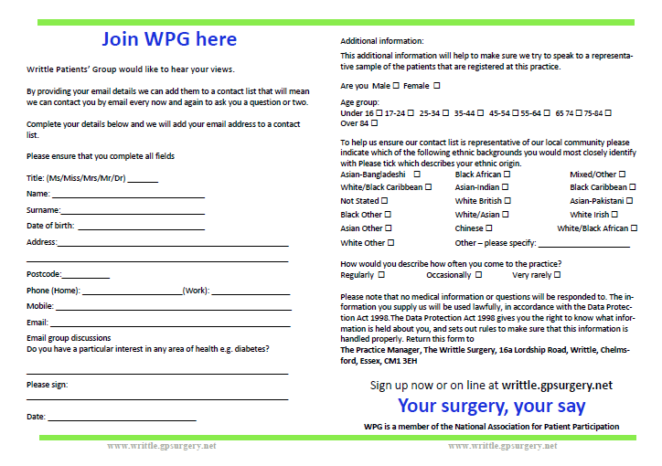
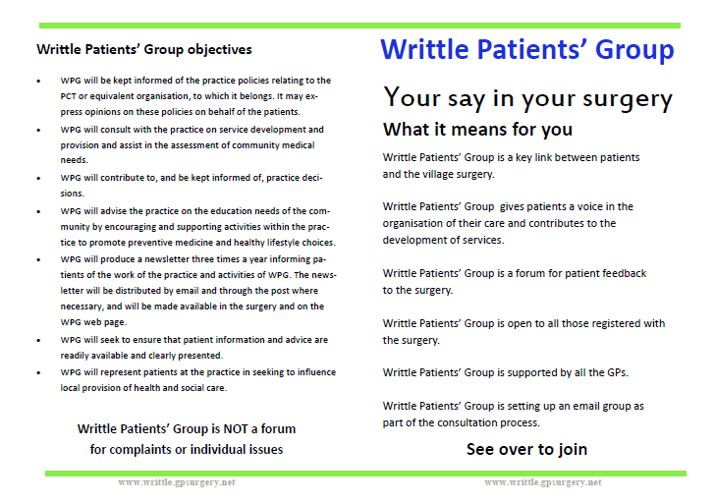

C) Agree with the patient representation group which issues are a priority and include these in a local practice survey

We held a patient meeting on Thursday 13th September at 7pm (appendix 1) , please see below for the agenda of the meeting. At this meeting we planned to discuss any issues that the group felt the surgery had through a practice survey.

The group discussed the priorities they wanted to focus on
- Patient education
- Reaching a variety of patients including travellers
- To educate patients about CCGs
- Appointment system
- Dispensary
- Card machine services
- Starting to look into 2013/14 funding

D) Obtaining patients views

The survey was
- Left on reception for patients to fill in
- Receptionists asked patients in the waiting room if they wished to fill it in
- Nurses mentioned it to patients
- PPG members told patients it was available
- Doctors gave them to staff members

100 responses were received in the two week period

Week commencing 24th September the questionnaires were anonymous and were folded in half and handed back to reception.

A copy of the questionnaire and results are available in appendix 2

E) The questionnaire results

collate patient views through local practice survey and inform PPG of the findings.

We were very pleased that we received 100 responses to the questionnaire. Rachel Maddock collated the Reponses from the survey and they are included in the survey results and action plan.

They were discussed in the meeting on 31st January 2013 (appendix 3)

F) Action Plan
see action plan and survey results attached

G) Evidence for action plan

The main statistics we have focussed on are as follows

- 94% of people who completed the survey were white British

- Of the 39 people who were able to collect their prescriptions from the surgery, 11% decided to go elsewhere to collect

- 64% thought it would be a good idea for the surgery to have the facility to make card payments

Areas for improvement

- 39% found it ‘fairly easy’ to book an appointment with the surgery, unfortunately that is down from 53% last year

- The free text comment section of the survey was the most interesting as patients were able to comment on the issues important to them
    - Opening hours
    - Waiting room
    - Appointments

H) actions to undertake

See attached plan

I) opening hours

Surgery opening hours: Monday-Friday 08:00-18:30.

Additional access can be sought through the practice website, requesting prescriptions, booking appointments etc.

J) Extended access

We offer extended access appointment on a Monday evening 18:30-20:00 and a Friday morning 07:30-08:00

Appendix 1
Writtle Patients Group (WPG)
Agenda for meeting to be held at the surgery on Thursday 13th September at 7pm

Apologies :

- Welcome & introduction of new members
- Minutes from June 21st and matters arising
- Election of new Chairperson and deputy
- Budget
- Surgery News
  - Patient Questionnaires - Rachel Maddock
- Project group actions and updates
  - Development and Admin
  - Publicity
  - Email/IT
  - Fundraising
- NAPP reports
- Moving forward
- AOB
- Dates for next meetings – 22nd November, 31st January 2013, 21st March (AGM) 2013

Writtle Patient Group (WPG)
Meeting held at Writtle Surgery on 13th September 2012 @ 7pm

Attendees : Bernard Bridges, Dianne Collins, Michael Heard, Stuart Rawlins, Catriona Hoffman, Christa Bringloe, Linda Deller, Phil Nunn, Margaret Loster and Avril Revell

From the Surgery : Dr Vincent and Rachel Maddock

Apologies : Sewleen Walker, Gordon Ingram, Jenny Black, Junita Prentice, Lauretta Fox, Beryl Sweeney

1. Welcome & Introduction of new members
Phil Nunn was welcomed to the group.

2. Minutes from last meeting and matters arising
All agreed that the minutes from the 21st June meeting were accurate.

3. Election of new chairperson and deputy
Unfortunately Mary Power has resigned as chair of the group due to personal reasons. Dianne Collins has volunteered to be chairperson and the group have agreed to this. Stuart Rawlins volunteered to be deputy chair and this was also agreed. Further to this, Jenny Black and Beryl Sweeney have resigned from the group as they do not feel that they can commit.

4. Budget
Stuart questioned whether the group had a budget available to them. Rachel has confirmed that possible funds are available depending on what they were to be used for.

5. Surgery news
Rachel had prepared a patient questionnaire that she distributed to the group for comment. Margaret suggested that it would be a good idea to have specific topics for people to comment on, i.e. opening times / car parking rather than just asking for general comments. It was also felt the free text section would be the most beneficial in changing the way the surgery works. It was also suggested that a section should be added to ask for peoples email addresses so that they can be added to the WPG email list to receive future communications. It was agreed this would wait due to patient confidentiality. The questionnaire would be dispersed mainly on the counter which the group agreed was a good idea, especially with flu clinics coming up, more people will be using the surgery than usual. The main question the group focussed on was whether patients felt a card machine would be beneficial and we hoped to get a good response on this question.

6. Project group actions and updates
Due to changes within the group, the structure of the subgroups has slightly changed to :
Admin & Development : Catriona, Dianne, Stuart and Rachel
Promotion & Publicity : Margaret, Avril, Christa, Lauretta, Bernard, Linda
Email & IT : Phil, Gordon, Michael and Junita
Fundraising : Sewleen and Michael

It was agreed that all subgroups will arrange to meet and report back at the next meeting.

Promotion & Publicity - Bernard reported that there had been very bad weather at the village fun day, meaning there was a disappointing turnout. Stuart had spoken with Mary regarding the poster she had designed to advertise the group and had produced a new leaflet which was distributed in its place. Stuart has also written the text to go in to the Writtle News, and other relevant village magazines in due course. Margaret talked about a festival at the church on the 1st and 2nd December, which she thinks it would be possible for the group to hand out leaflets. It was suggested that it would be a good idea for someone within this subgroup to prepare and maintain a list of all upcoming events in Writtle and the surrounding relevant villages. The leaflets that Stuart has prepared should also be distributed around the villages, remembering that not everyone has access to emails.

7. NAPP Reports
Dianne read through the latest NAPP reports. All newsletters will continue to be distributed by Catriona via email and Dianne has requested that all members read through these and we can discuss any interesting findings or ask any questions arising from these newsletters at meetings.

8. Moving Forward
The current aim of the group is to get around 200 people to agree to be recipients of emails. Dianne suggested it would be a good idea to get people to give their age when they sign up so that they can be sent more relevant questionnaires, but it was decided that it would be better to send all questionnaires to all members of the mailing list.

9. AOB
Dianne suggested a rota for all WPG members to sit in the waiting room and try and encourage people to join the mailing list, however it was decided that this was not a good idea.

Bernard suggested the idea that WPG use the surgery logo as their logo, but as the group is independent from the surgery Rachel has offered to design some logos in time for the next meeting.

Stuart requested that someone comes to talk to the group regarding the Clinical Commission Group and Rachel is going to arrange for Lisa Finch from the EGPC to do so.

Rachel informed the group that Dr Bailey has been trying to contact the traveller lady who he was going to ask to come and talk to the group but unfortunately this has been without success so far.

Catriona will contact the chairperson from Danbury Medical Centre who Mary met with previously, and has agreed to come and talk to the group on their successful patients group. This will be arranged for a Thursday evening between now and the end of the year and all members of the group will be informed accordingly.

10. Next Meeting
The next meeting will be held on Thursday 22nd November.
Further meeting dates are :
- Thursday 31st January 2013
- Thursday 21st March 2013 (this will be the AGM)
After this meeting Rachel Maddock amended the questionnaire taking into account all the suggestions made by the group. It was printed and placed onto the reception counter, patients will be encouraged to fill the questionnaire in.

The group and practice were interested in seeing whether patients would like a card machine installed at the surgery.

Appendix 2
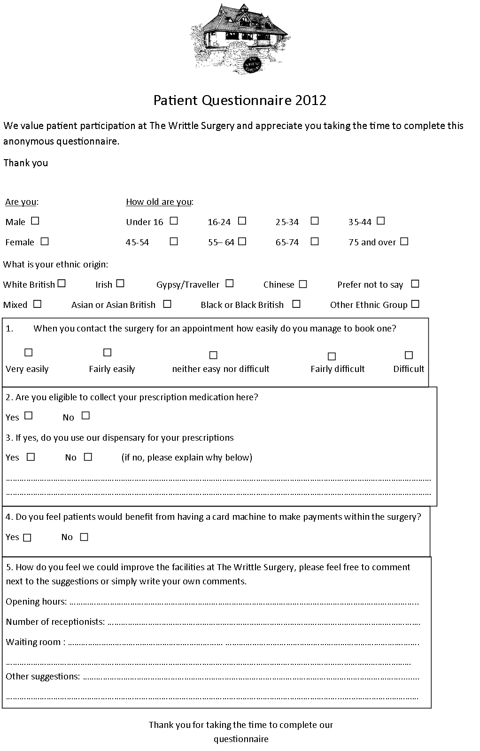
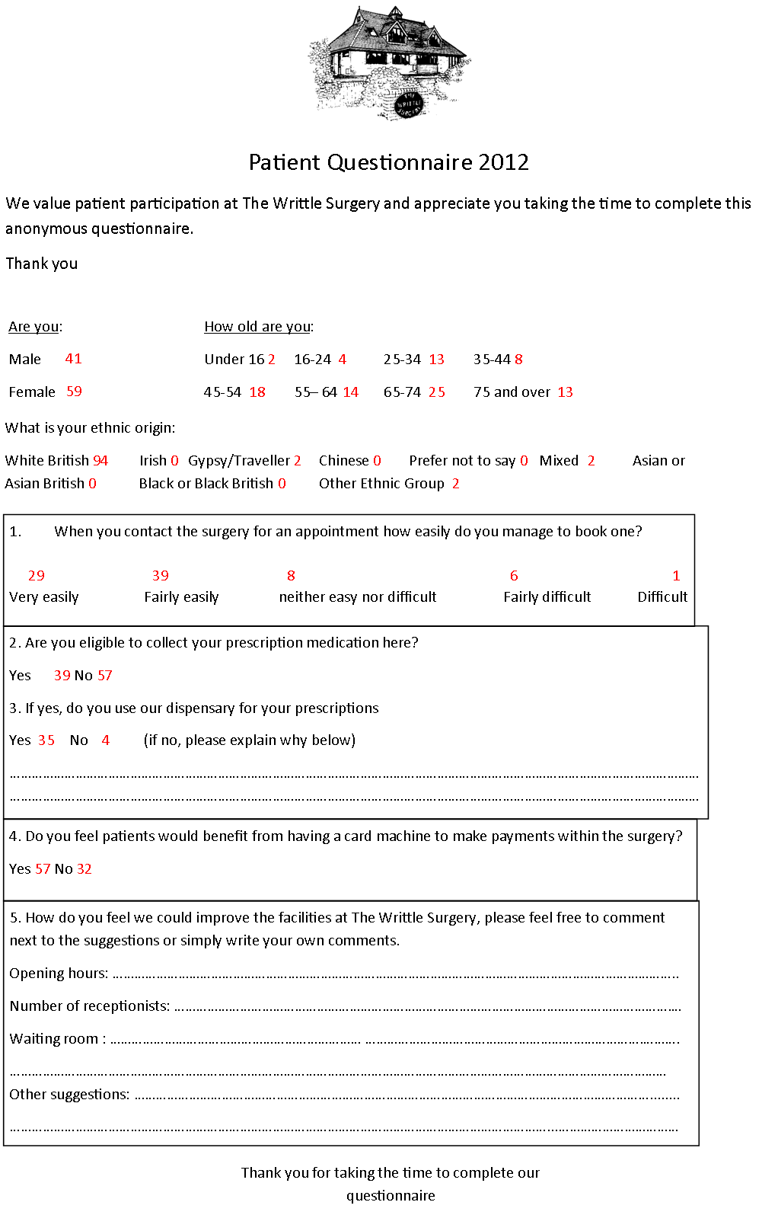

Appendix 3

At the meeting on 31st January 2013 the results of the survey were discussed.

Writtle Patient Group (WPG)
Meeting held at Writtle Parish Rooms on Thursday 31st January 2013 at 7pm

Attendees : Dianne Collins, Michael Heard, Stuart Rawlins, Christa Bringloe, Phil Nunn, Sewleen
Walker, Catriona Hoffman, Lauretta Fox, Margaret Loster and Avril Revell
From the Surgery : Dr Wood and Julie Robinson

Apologies : Bernard Bridges and Linda Deller (resigned from group)

1. Welcome

2. Minutes from last meeting and matters arising
All agreed that the minutes from the 22nd November 2012 meeting were accurate.

3. Budget
Stuart informed the group that the City Council have a scheme that offers a grant to community
groups that we could possibly apply for (up to £1000), and also we discussed applying for the
“Awards For All” grant again. It was agreed that in order to make such applications we would need to set up a bank account and elect a treasurer. Dr Wood suggested that we would possibly be able to open an account through the main surgery account which Rachel would be able to control at the start whilst the group gets more established. He will confirm if this is possible. Christa suggested that if we need to find a treasurer we could try the Voluntary services group in Chelmsford, but later in the meeting Phil offered to be treasurer and research bank accounts (The
Cooperative bank was suggested). He will report back at the next meeting.

4. Surgery news
Julie informed the group of the results of the questionnaire which was handed out in the surgery along with some statistics. Approximately 100 completed questionnaires were returned which Dr Wood said was a good response. The group were pleased to see that of the 100 questionnaires, 64% felt it would be good to have a card machine. The things people had commented on were, parking, waiting room, dispensary and the appointment system. It was discussed in detail (see below) about the change in appointment system and how this would help relieve pressure in the waiting room, parking and appointment system.

Dr Wood also informed us that there had been some feedback on the surgery on the NHS
Choices website which had been positive (This can be viewed here Surgery Review (NHS Choices)
Dr Wood informed us that the NHS Direct system will be replace by NHS111. It is hoped that this
should be a seamless transition and the idea is that this will advise you whether you need to visit a
doctor or not. In other surgery news, are to be some changes to staffing. Dr Bailey is going to go part time so will be working 3 days instead of 5, and Dr Vincent and Dr Wood will also be reducing by 1 day a week. A new doctor, Dr Raina Shah will be starting on the 4th March, and once in place they will be looking at ways to make their working days more effective. The dispensary is being extended to the rear to allow more room, and to enable people to be able to have more private discussions where necessary. The dispensary will also be able to take credit / debit cards in the near future.

5. Project group actions and updates
Development and Administration Dianne has not been able to contact another PPG as yet. She is
going to ask at the next Link meeting to see if anybody there can help. Promotion & Publicity – Stuart has designed a logo, 2 were shown to the group and a blue and green one was chosen (these are the same as the colours used by the surgery). Using the surgery logo was discussed but ruled out because the PPG is separate from the surgery. Christa reported that over 1,000 people visited the Xmas tree festival and that they made over £3500. Next year the festival will be held on the 7th and 8th December. Dianne thanked those who were involved with decorating the tree. Unfortunately not many leaflets were taken from the event. Dr Wood suggested it would be a good idea to give out leaflets at the dispensary. NAPP have a
‘Patients Awareness Week’ from the 3rd to the 8th June. It was agreed that this would be a good time to distribute leaflets via the dispensary and that possibly the surgery could be opened on a Saturday morning during this week to raise patients awareness on the surgery and PPG. It was agreed that the publicity group would meet and discuss this and report back at the next meeting.
Avril advised the group that the press release went out in the Roxwell Recorder.
Fundraising – Michael and Sewleen have researched the idea of the raffle and it was agreed that they would start asking for prize donations ASAP. It was agreed that the raffle would run in conjunction with the Patients Awareness Week. A license would be needed for the raffle.
Email & IT Gordon has suggested that we will need a central server to send emails from, and that
we will need the relevant equipment to be able to do this. The lady who set up the village website
would be interested in doing a website for the group and Gordon is going to confirm with her the price and report back at the next meeting.

6. NAPP Reports
Dianne read through the latest NAPP reports. All newsletters will continue to be distributed by
Catriona via email and Dianne has requested that all members read through these and we can
discuss any interesting findings or ask any questions arising from these newsletters at meetings.

7. Link Meetings
Dianne confirmed that these meetings are beginning to wind down and that they will turn them in to
‘Health Watch’ meetings. The next meeting will be held on the 14th February and Dianne, Phil and
Christa will attend on behalf of the group.

8. AOB
Dianne has requested that all parish councillors are added to the email list (David Walker to send
details to Catriona) and Julie is going to send Catriona a list of contacts for the other parishes that the surgery covers.

9. Next Meeting
The next meeting, which is also the AGM, will be held on Thursday 21st March 2013 at 7pm at the
Writtle Parish Rooms

The Writtle Surgery

Survey results and Action Plan
2012/2013

The Writtle Surgery

Patient participation group survey results and action plan
Introduction
We based some of the questions on the previous year’s questionnaire so that there would be some comparison in results. This year however we created a more specific short questionnaire to encourage patients to complete it, including the issues the PPG felt were most important.
The survey took place week commencing 24th September during this time patients were asked to complete them, we did not ask patients to take the questionnaires away as we felt this would reduce the rate of responses. We received 100 completed surveys.

Key statistics
- 94% of people who completed the survey were white British

- We had a good split of male to females completing the survey, 41% male and 59% female

- Only 1% said they found it ‘difficult’ to book an appointment at the surgery, which we found positive

- Of the 39 people who were able to collect their prescriptions from the surgery, 11% decided to go elsewhere to collect

- 64% thought it would be a good idea for the surgery to have the facility to make card payments

Areas for improvement

- 39% found is ‘fairly easy’ to book an appointment with the surgery, unfortunately that is down from 53% last year

- The free text comment section of the survey was the most interesting as patients were able to comment on the issues important to them (we have focussed on these five areas in the action plan)
    - Appointments
    - Dispensary
    - Opening Hours
    - Waiting Room
    - Parking

Installation of a card machine
64% of patients thought it would be a good idea to have a card machine installed in the surgery to enable card payments, mainly at dispensary but also for jabs and medicals.

This had been an area that the PPG were extremely interested in setting up, as we felt it would be easier for patients. So we were very pleased with the result of this question.

Action plan
- In line with the new dispensary extension opening we will be installing a card machine and till
- This will enable patients to pay for a number of services throughout the surgery by card.

Appointments
Unfortunately it is disappointing that we saw a reduction in the amount of people who found it easy to book an appointment, we hope with the changes we will make in this coming year that next year there will be an improvement.

We have discussed with the PPG about changing the appointment system. The current appointment system is historic and has not changed even through patient demand has increased significantly.
The surgery has taken part in the primary care foundation toolkit (awaiting results) which will highlight areas of improvement.

Action plan
- Patient education through PPG of booking appointments
- Publicise the availability of booking appointments online
- GPs to consider results once published

Dispensary
Do you use the dispensary to collect your medication (if eligible) ?
There was an option to free text this after a ‘yes or no’ tick box. Of the patients who said no their reasons for not using the dispensary were
- Rather use the local chemist
- Walk past chemist on way home
- Poor customer service
- Chemist

Verbal comments made throughout the year are raley about medication or repeat prescription service which we feel is positive, we would just like all patients who are able to use the service to utilise it.

We will be sending the reception staff and dispensers on customer service training courses in the next year.

We are currently having an extension to the dispensary this should elevate some pressure and waiting time for patients as the space will be increased. There will be a second hatch added, for privacy and also to see more people at once.

Unfortunately by their own admission dispensers are often short with patients, not because they are rude but simple due to time pressures and often a queue at the hatch.

Action plan
- Staff training
- Advise patients to raise concerns if not happy

Opening hours
We had a number of comments in the free text section about opening hours. (appendix 1)
Our surgery is open 08:00-18:30 daily. We would not want to increase these hours due to cost, staff pressures and capacity.

Many patients commented they would like weekend opening hours. Unfortunately the surgery used to open on a Saturday morning for commuters and workers, however more often than not it was retired patients who booked the surgeries, therefore not fulfilling its intended purpose.

We do however offer flu clinics on a Saturday.
A number of patients also commented on late night opening.We do in fact open early on a Friday morning for extra appointments and late on a Monday evening, until 20:00.

Action Plan
- Publicise late night and early morning openings
- Unlikely to increase opening hours, but we are looking into access eg more phone triage.

Waiting Room
Again In the free text section of the survey patients wrote a number of comments about the waiting room. The main observations listed below,
- Kids area
- Temperature
- More seats
- Magazines

It is understandable that patients get frustrated when they are unwell and are faced with a full waiting room.

Unfortunately our waiting room is rather small and when the ‘extras’ surgery begins at 10.30am it often becomes overcrowded with patients having to stand due to lack of seating. Unfortunately we are at full capacity for seating in the waiting room. When the appointment system is changed the capacity in the waiting room will be better as patients will be spread out throughout the day.

The heating in the building is controlled by one thermostat so again when the waiting room becomes full patients often say it is too hot, but the staff upstairs would say it is too cold!

Two people commented on having a water fountain. Unfortunately this would be an additional cost and potential wastage; it would also be at children’s height for them to touchand play with – infection control risk. If however a patient would like a glass of water when in the waiting room, they only need ask reception who would fetch one.

Many commented on the lack of magazines. The magazines and rack were removed during swine flu due to cross infection risk.

However this is something we are looking into reinstating, as we like to try and keep patients happy, also due to having such a small waiting room patients are able to hear receptionists on the phone. If people are reading it may cut down on how much they are listening to reception.

Action plan
- The 10.30 am ‘extras’ list will be removed when the new appointment system starts, this should mean a steady flow of patients and therefore the waiting room may not be so crowded.

Parking
Of the free text comments many were about parking at the surgery, many commented on the lack of a disabled bay.

Many of the comments were about the amount of parking spaces. Unfortunately at 10.30am when our ‘extras’ clinic begins the car park becomes very full.

This also causes a safety issue as Doctors are often blocked in, when they may need to leave the building due to an urgent visit.

There is no potential to increase on site parking. We have an unmarked staff parking area as many of our staff drive, however patients do not always take as much care as they should and there have been incidents of damage to vehicles in the car park.

For disabled patients, there is a large drop off space at the front of the surgery next to the disabled ramp. There is also a long layby directly outside the surgery if more access to the back of the vehicle is required, for example to unload a wheelchair.

Action plan
- Through PPG educate patients about parking and the lack of space and to take care when parking
- Ensure staff park tidily and to not block doctors in.

Conclusion
To put all plans In place in time for the survey to be repeated in 12months time.

Appendix 1 (a selection of the free text comments)
How do you feel we could improve the facilities at The Writtle Surgery, please feel free to comment on the suggestions we have made ( opening hours, number of receptionist, waiting room) or simply write down your own comments.

Opening hours
- The opening hours suit me
- Have soothing background music if you must have music at all. Radio blaring out just irritates my symptoms and I’m uptight by the time I go in to doctor
- More reading material
- Evenings perhaps one night per week
- Apart from Monday perhaps another late night
- Saturday morning please
- Being able to book appointments more than 2 weeks in advance
- Would prefer weekend open hours. Very nice waiting room
- It would be nice to have a doctor here at the weekend
- Keep some appointments free so people don’t have to just ring at 8am and 2pm
- Worrying at bank holidays and weekends
- Weekend opening would be preferred

Waiting room
- Temperature-not so hot
- Occasionally more seating however this is only very rarely needed
- Drinking water machine
- Water in waiting room and magazines
- Can be to warm or really hot, not good for passing on infection
- Could do with more reading material is this allowed? I feel the surgery copes well with the amount of patients you see, but all NHS services are at breaking point by the amount of people using them every day
- Kids area, books and toys
- More seats
- Water cooler in waiting room

Parking
- Parking for wheelchair users not easy
- Parking facility for disabled wheel chair users would be extremely helpful
- Disable parking bay
- Parking need more space
- Take action for better parking on the muddy areas towards the college
General
- Informed of times and changes as I do not come in every often
- Dispensary open all day
- Extend prescription facility

Appointments
- More flexibility for booking appointments for people who work in London
- More flexible with after school appointments
- More surgeries between 9-5
- People wasting the doctors time, with minor illness they would be better off going to get something from the chemist or supermarket instead of doctors
- Short waiting times for appointments would be nice
- Should be more hours in the day to see doctor, all blood tests to be done at the surgery
- Evening surgery
- Evening opening
- A longer day would surely make more bookable appointments with the 2 week window

Other Comments
- The surgery runs extremely well as it is
- Very good
- I find it good as it is
- None, my experiences with the surgery have always been good
- Works well as it is
- Cannot fault surgery or staff including all staff in every department always helpful and supportive and make things happen whenever they can
- The system seems to be running smoothly as it is
- Quite happy with the existing arrangements
- Usually short wait time on the phone, everything seems to work well
- No suggestions perfectly happy with surgery and facilities and hours
- This is my first visit to the surgery, so can’t comment at this stage but all seems good so far

Agendas of Meetings
May meeting

Writtle Patients Participation Group
Agenda for foundation meeting
May 10, 2012, Writtle Surgery, 7pm
1 Welcome and introductions

2 Election of
Chair
Secretary
3 Confirmation of Aims and objectives

4 Group structure

5 Development plan

6 Promoting WPG

7 Practice developments/news

8 AOB

9 Dates of next meetings

Your action points –

June Meeting
Writtle Patients Group (WPG)
Agenda for meeting to be held at the surgery on Thursday 21st June 2012 @ 7pm

Apologies : Sewleen Walker, Gordon Ingram, Jenny Black, Avril Revell

1. Welcome
2. Last minutes from May 10th agreed and discuss any matters arising from the minutes
3. Election of deputy chair & treasurer
4. Reminder of ground rules
5. Confirm subgroups
- Development Plan / Promotion / Publicity – Stuart, Avril, Christa & Lauretta
- Email / IT – Margaret, Gordon, Junita & Jennifer
- Administration – Catriona, Mary, Surgery staff & Deputy chair (TBC)
- Fundraising – Helen, Dianne & Sewleen
6. Presentation by Rachel, Practice Manager
7. Fundraising / NAPP membership
8. Marys meeting with Chair of Danbury Medical centre
9. Group structure
10. Future speakers – potential Eleanor Dove, Receptionist, Practice nurse
11. ‘Leap Against Stigma’
12. AOB
13. Date for next meeting

September meeting
Writtle Patients Group (WPG)
Agenda for meeting to be held at the surgery on Thursday 13th September at 7pm

Apologies :

- Welcome & introduction of new members
- Minutes from June 21st and matters arising
- Election of new Chairperson and deputy
- Budget
- Surgery News
  - Patient Questionnaires - Rachel Maddock
- Project group actions and updates
  - Development and Admin
  - Publicity
  - Email/IT
  - Fundraising
- NAPP reports
- Moving forward
- AOB
- Dates for next meetings – 22nd November, 31st January 2013, 21st March (AGM) 2013

Action points:

November meeting
Writtle Patient Group (WPG)
Meeting held at Writtle Surgery on 22nd November 2012 @ 7pm

Attendees : Dianne Collins, Michael Heard, Stuart Rawlins, Christa Bringloe, Phil Nunn and Sewleen Walker
From the Surgery : Dr Bailey and Julie Robinson
Apologies : Bernard Bridges, Linda Deller, Catriona Hoffman, Margaret Loster, Avril Revell and from the surgery Rachel Maddox

1. Welcome
2. Minutes from last meeting and matters arising
3. Budget
4. Surgery news and questionnaire
6. Project group actions and updates
7. NAPP Reports
8. Christmas Tree Festival
9. AOB
10. Next Meeting
- The next meeting will be held on Thursday 31st January 2013

Further meeting date is :
- Thursday 21st March 2013 (this will be the AGM)
All meetings are to be held at 7pm

January meeting

Writtle Patients Group (WPG)
Agenda for meeting to be held on Thursday 31st January at 7pm at the Parish Rooms
____________________________________________________________________________
_
- Apologies
- Welcome and introduction of new members
- Agreement of the minutes from the last meeting
- Budget
- Surgery news
- Patient questionnaires (Rachel)
- Project group actions and updates
- Development and admin
- Publicity
- Email / IT
- Fundraising
- Group Logo
- NAPP Reports
- Link meetings
- Development plan
- AOB
- Next meeting - 21st March 2013 AGM

