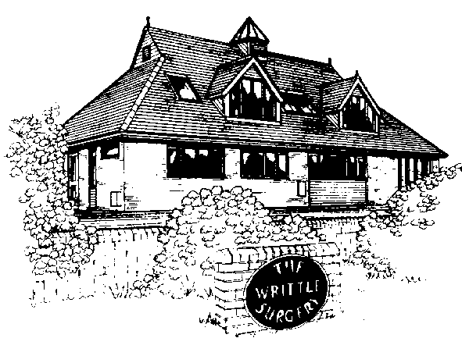

The Writtle Surgery

Patient Participation Group Report

2013/2014

The Writtle Surgery

16a Lordship Road

Writtle

Chelmsford

CM1 3EH

Dr Bailey, Dr Wood, Dr Vincent, Dr Wilson and Dr Sodha.

**The Writtle Surgery**

**Patient Participation Group Report 2013/2014**

*The Patient Participation Group at The Writtle Surgery was set up in late October2011, to understand the views of patients on the services that the Writtle surgery offers, it is also a way of involving patients in shaping the future of Primary Health Care. The group has met periodically to discuss any improvements that could be made to improve our services. The patient group has already helped shape changes within our practice and will also be consulted when we change our appointment system later this year. Between meetings the group keep in touch and communicate using email so that we are all kept up to date with the implementation of NHS changes both at Practice Level and national level.*

This Report includes

* Practice Profile
* PPG group profile
* Patient questionnaire
* Action plan and survey results
* Patient comments on survey
* Agendas of PPG meetings

**Introduction**

In 2011 the government launched a new ‘direct enhanced service’ (DES) for Patient Participation Groups (PPGs). The aim of this direct enhanced service was to encourage dialogue and involvement between GP practice and their patients.

This report is intended to be read by all patients, PPG members, members of the local community, the CCG and NHS England.

Our list size as of 1/04/2013 excluding all patients 15 years and under is 6696 and of those 4675, almost 70% are registered as white British (not all are coded) .

The Writtle Surgery Practice Information

Practice Profile

Our Practice population is almost 7,900 of which a quarter are over 65 years. It is centred in Writtle village with a population of nearly 5,500. Within the Practice area there are two sizeable villages of Roxwell and Good Easter, plus the hamlets of Highwood, Cooksmill Green, Chignal St James and about half of Willingale. The Practice is semi-rural with high quality farmland (mainly arable) and includes nearby Hylands Park.

Our reception hours are 8am-18.30 and our opening hours are 8.15am-18.00. patients can access and obtain our service throughout these hours. When patients phone the surgery outside of these hours they are directed to 111 on the telephone system.

We have patient leaflets available throughout the surgery which explain all about the surgery.

Many of our patients work in Chelmsford, Brentwood or commute to London. A quarter of our patients are defined as rural. This applies to sparsely settled areas of agricultural countryside and includes those patients living more than 3 miles from the surgery. Historically we carry out a higher proportion of home visits than an urban Practice because of inadequate public transport. The village has three Showman (fairground) sites and there is a 16 pitch ECC Traveller site just beyond the village boundary.

Adjacent to the surgery is Writtle College, part of Essex University. The student population has recently increased significantly and presents its own challenges for the Practice to handle. Students are drawn from the UK and abroad, including Africa, mainland China and Japan.

Within the Practice area there is one sheltered housing unit of flats and bungalows and a Springboard Housing Trust of 34 warden controlled flats.

1) DEVELOP A STRUCTURE THAT GAINS THE VIEWS OF PATIENTS AND ENABLES THE PRACTICE TO OBTAIN FEEDBACK FROM PATIENTS, A PRG.

Group Profile

Face to face group

5 female and 2 male.

* Male, aged 72, Caucasian, retired but involved in many different volunteer groups, regular user of surgery.
* Female aged 64 Caucasian, not a regular user of the surgery, two children
* Female 32 Asian, regular visitor with two young children
* Male aged 67 Caucasian, regular visitor to the GP surgery, registered at practice since birth, retired.
* Female aged 57 Caucasian regular user of the surgery, teacher, three female children
* Female aged 67 Chinese, retired nurse, not very regular user
* Female aged 68 Caucasian regular user of the surgery, one son, retired but involved in many charities.

Virtual Group

* The group are yet to implement a virtual group; this is an aim for them.

Writtle Patients group website

* The group worked hard during the year with the owner of the Writtle Village website, to secure a page there. This includes information about the patients group <http://www.writtlevillage.com/patients.html>

Establishing a PPG

We felt it would be important to have a group which represented a wide range of patients both male and female and who also represented the different demographic groups including, for example, travellers and students. We also would look to include members from within minority categories including those with physical disabilities and long term conditions.

We have taken steps throughout the year to recruit new members including

* Writtle surgery newsletter
* Patient survey, whereby they can leave an email address
* Posters in the waiting room
* Advertising on website
* Poster in local library and parish notice board
* Sign up sheets (shown below)
* Patients approached directly by GPs and Nurses
* Publication in Writtle parish magazine (as shown below)

It is unfortunate that after publicising our group in all these different ways that our group are mainly made up of white British, we do however have one Asian and one Chinese member. It is hoped that with the events being held throughout 2014 in the village the profile will be raised.

Our GPs have actively encouraged students and also traveller communities to be included but so far none have decided to take part.

However we do feel that our group covers a wide range of the population.

Publication in Parish News

# **Writtle Patients’ Group**

A new group has been launched in Writtle to give patients a voice in their health care at the village doctors’ surgery.

Writtle Patients’ Group aims to be a key link between patients and the surgery and become a forum for feedback and consultation said the group’s chairperson Dianne Collins.

With five GPs, Writtle Surgery has nearly 8,000 patients and as well as the village, covers Roxwell, Highwood and part of west Chelmsford. The patients’ group is led by a team of 14 volunteers and is now setting up an email group to widen consultation among villagers. The group is supported by doctors and staff at the Lordship Road surgery.

Dianne Collins said: “Any patient registered at Writtle Surgery, can become a member of the email group. We want to help the surgery develop its services and for people to take more responsibility for their own health. We’re not, however, a forum for complaints or individual issues.”

Starting an email group, she said, means that it will be easier and quicker for people to be consulted about health issues. Patients can join online at *writtle.gpsurgery.net*, or complete a form at the surgery’s reception.

She added: “We really want community involvement and to help the GPs and their staff to give patients the best possible care.”

Writtle Surgery practice manager Rachel Maddock said: “This is a fantastic opportunity for the Writtle surgery community to become involved with changes, not only within the surgery but within the ever changing NHS. I would urge anyone who is interested to call into the surgery and leave their details. I am really looking forward to the patient participation within Writtle Surgery.”

After agreement with the surgery, the WPG defined its role to cover the following points:

* WPG will be kept informed of the practice policies relating to the Primary Care Trust/Clinical Commissioning Group or equivalent organisation, to which it belongs. It may express opinions on these policies on behalf of the patients.
* WPG will consult with the practice on service development and provision and assist in the assessment of community medical needs.
* WPG will contribute to, and be kept informed of, practice decisions.
* WPG will advise the practice on the education needs of the community by encouraging and supporting activities within the practice to promote preventive medicine and healthy lifestyle choices.
* WPG will produce a newsletter three times a year informing patients of the work of the practice and activities of WPG. The newsletter will be distributed by email and through the post where necessary, and will be made available in the surgery and on the WPG web page.
* WPG will seek to ensure that patient information and advice are readily available and clearly presented.
* WPG will represent patients at the practice in seeking to influence local provision of health and social care.

The group is affiliated to the National Association for Patient Participation, website *napp.org.uk*, which promotes patient involvement in the health service. Patient groups are part of NHS reforms to involve and consult patients and the public in planning and development of services.

Sign up sheet

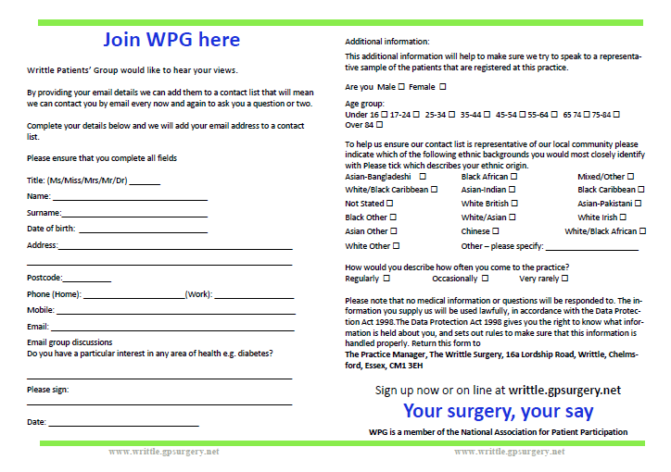

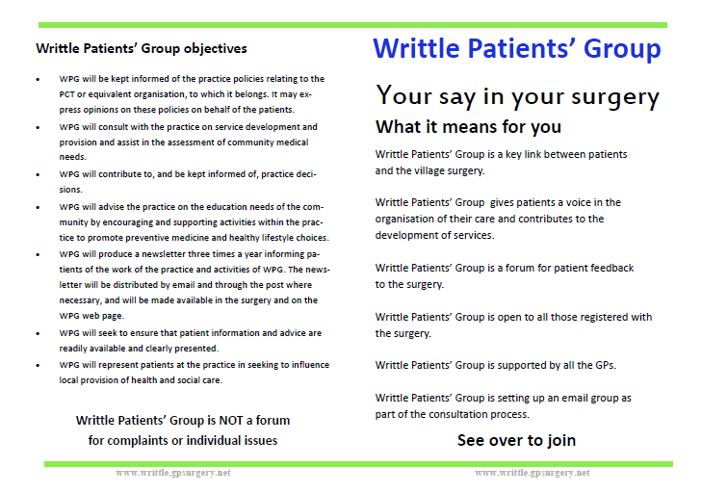

3) Agree with the patient representation group which issues are a priority and include these in a local practice survey

We held a patient meeting on Thursday 4th July 2013 (appendix 1) , please see below for the agenda of the meeting. At this meeting we planned to discuss any issues that the group felt the surgery had through a practice survey. The survey was then created by the practice manager and sent via email to the chair and secretary of the group, who confirmed it met their wishes.

The group discussed the priorities they wanted to focus on

* The new appointment system at the surgery and whether patients feel it is improved
* The layout of the receptionists in the waiting room
* Patients education, what services are patients aware of
* Using the opportunity for patients to leave their email addresses to join the virtual group.
* How easy or difficult it is to get an appointment by phone.

4) COLLATE PATIENTS VIEWS THROUGH THE USE OF A SURVEY

The survey was

* Left on reception for patients to fill in
* Receptionists asked patients in the waiting room if they wished to fill it in
* Nurses mentioned it to patients
* PPG members told patients it was available
* Doctors gave them to staff members

100 responses were received in the two week period, we printed 105 surveys and so our return rate was fantastic.

Week commencing 14th October 2013 the questionnaires were anonymous and were folded in half and handed back to reception.

A copy of the questionnaire and results are available in appendix 2.

4) PROVIDE THE PRG WITH AN OPPORTUNITY TO DISCUSS SURVEY AND FINDINGS AND REACH AGREEMENT ON CHANGES TO THE SERVICE

PATIENT QUESTIONNAIRE RESULTS

We were very pleased that we received 100 responses to the questionnaire. Rachel Maddock collated the Reponses from the survey and they are included in the survey results and action plan.

They were discussed in the meeting on 7th November 2013 (appendix 3)

Our changes made were not significant enough to inform NHS England, however they will receive a copy of this report.

5) AGREE ACTION PLAN WITH THE PPG AND SEEK THEIR AGREEMENT TO IMPLEMENT CHANGE

See action plan and survey results attached (appendix 4)

Our previous action plan 2012/13 is included in appendix 8 and in red font highlights the actions we have implemented.

Key statistics

* 100% of people who completed the survey were white British, this was a disappointing figure as even though we tried to target patients in waiting room and consulting room only white British people completed the survey. We have a broad range of patients who visit the surgery and receptionists and GPs did actively encourage patients to complete the questionnaire.
* 69% of people were very satisfied in their care at the surgery
* Only 30 people were aware that appointments could be booked online
* 63 people knew that blood tests could be taken at the surgery

Areas for improvement

* 69% of people surveys said that although they can sometimes be overheard in the waiting room, they did not mind
* We were pleased to see an improvement, that 43% of people found it ‘fairly easy’ to book an appointment that is compared to 39% in 2012/2013, and 53% in 2011/2012. We have recently changed our appointment system and are pleased to see it working as there is a slight improvement in peoples opinions from previous year
* The free text comment section of the survey was the most interesting as patients were able to comment on the issues important to them
  + - Appointments
    - Opening Hours
    - Waiting Room

H) actions to undertake

See attached plan

I) opening hours

Surgery opening hours: Monday-Friday 08:00-18:30.

Additional access can be sought through the practice website, requesting prescriptions, booking appointments etc.

STEP 6) PUBLICISE ACTIONS TAKEN AND SUBSEQUENT ACHIEVEMENT. (on website)

Writtle Patients Group (WPG) achievements and events throughout the year

* Writtle Surgery partners donated £500 to the WPG, they wanted to start fundraising but could not do this without initial monies and a bank account.
* Throughout May the WPG decided to hold a fundraising event in way of a raffle. Please see appendix 5 for the poster. This raffle raised money to enable the group to hold further events and talks
* During the year unfortunately our minute taker resigned from this role, although she remained as part of the group, the advertisement for her replacement is in appendix 6
* The group held a patient education event on 18/11/2013 they have invited a local diabetes speaker; a doctor from writtle surgery will also be in attendance as well as our lead diabetic nurse. Poster in appendix 7 this event was very successful.
* The first AGM was held in March (appendix 4)

Conclusion

* There have been positive influences made from the input of the PPG including the changing of the appointment system and its subsequent success
* We are now looking into the changing of nurse appointments and publicising to patients what they can treat to free some GP appointments
* We will also publicise that patients can have confidential conversations should they wish
* We are high QOF achievers for patient experience
* We hope to help publicise the PPG more and carry on with their continued success
* We will continue to support the PPG in all their events throughout the year
* We will publicise this report to our practice population via the website upload, poster in waiting room and
* a copy of the report will also be emailed to the PPG chair.

Appendix 1

**Writtle Patients Group (WPG)**

**Agenda for meeting to be held at the Parish Rooms on Thursday 4th July 2013 at 1pm**

Apologies :

1. Welcome & introduction of new members
2. Admin Group Report
3. Publicity Group Report
4. Treasurer’s Report
5. Website Update
6. Surgery News
7. AOB

To be held in the Parish Rooms

5th September 2013

7th November 2013

13th February 2013

AGM 20th March 2014

Meeting where the priorities of the survey were discussed

**Writtle Patient Group (WPG) AGM**

**Meeting held at Writtle Parish Rooms on Thursday 4th July 2013 at 1.p.m.**

Attendees: Dianne Collins, Christa Bringloe, Bernard Bridges, Avril Revell, Phil Nunn, Rachel Maddock and Dr Wilson

Apologies: Stuart Rawlins, Sewleen Walker, Margeret Loster, Gordon Ingham (apologies received by e-mail after meeting)

1. Welcome to two representatives from Prime care Sarah Millbank and Kelly Richard who represent the out of hours service used by the surgery

Minutes from the last meeting held 4th July 2013 were agreed

1. Publicity Group: It was suggested that for the Christmas Tree Festival to be held the first weekend in December that thought be given to creating a tree that reflected the surgery. I.e. a tree hung with the paraphernalia of the surgery.

Secondly we should begin at the next meeting to gather ideas for prizes for the next patient draw and it would be helpful if the surgery could suggest something that we could work towards providing.

1. Treasurers Report. Phil Nunn reported that we now had a bank account with cheque book bank cards etc.

1. Website. As Gordon was not present there was no report regarding the website.
2. Admin Group It had not met since the last meeting.
3. Recruiting committee members. Christa volunteered to contact Hylands School to see if we could attract a representative from the schools sixth form. It was also suggested that it would be a good idea to go to the Writtle College during Freshers week.
4. Surgery News

There were now leaflets available regarding the new appointments system. Rachel is to send a copy to Gordon for the internet. Patients are now able to register and book on line. Dr Sodha is now settled into the surgery as the new partner and there is a new dispenser called Alison.

The extension has been finished

There are now more hours for patients to get an appointment with Lisa working Wednesday and Friday mornings. The lists are now pooled with patients being given appointments with whoever is available.

Letters are being sent out to everyone who has not been to the surgery or had a home visit for over two years to say that their name is being removed from the surgery list. Anyone receiving a letter who still wishes to be on the list needs to contact the surgery. This exercise is to ensure that people who have moved away are not artificially inflating the list. Rachel discussed the patient survey and using it as a basis to inform patients of the WPG, the priorities of the survey were discussed including the new opening hours, the waiting room, ease of getting an appointment and effectiveness of telephone service.

The representatives of Primecare explained that they provide the out of hours service for the surgery. Patients who require advice or a visit out of hours should continue to dial the surgery number. This puts them through to Primecare. It was emphasised that the 111 service is not used by the Writtle surgery.

1. AOB there being none the date of the next meeting was agreed as 5th September at

the Parish Rooms 7.p.m

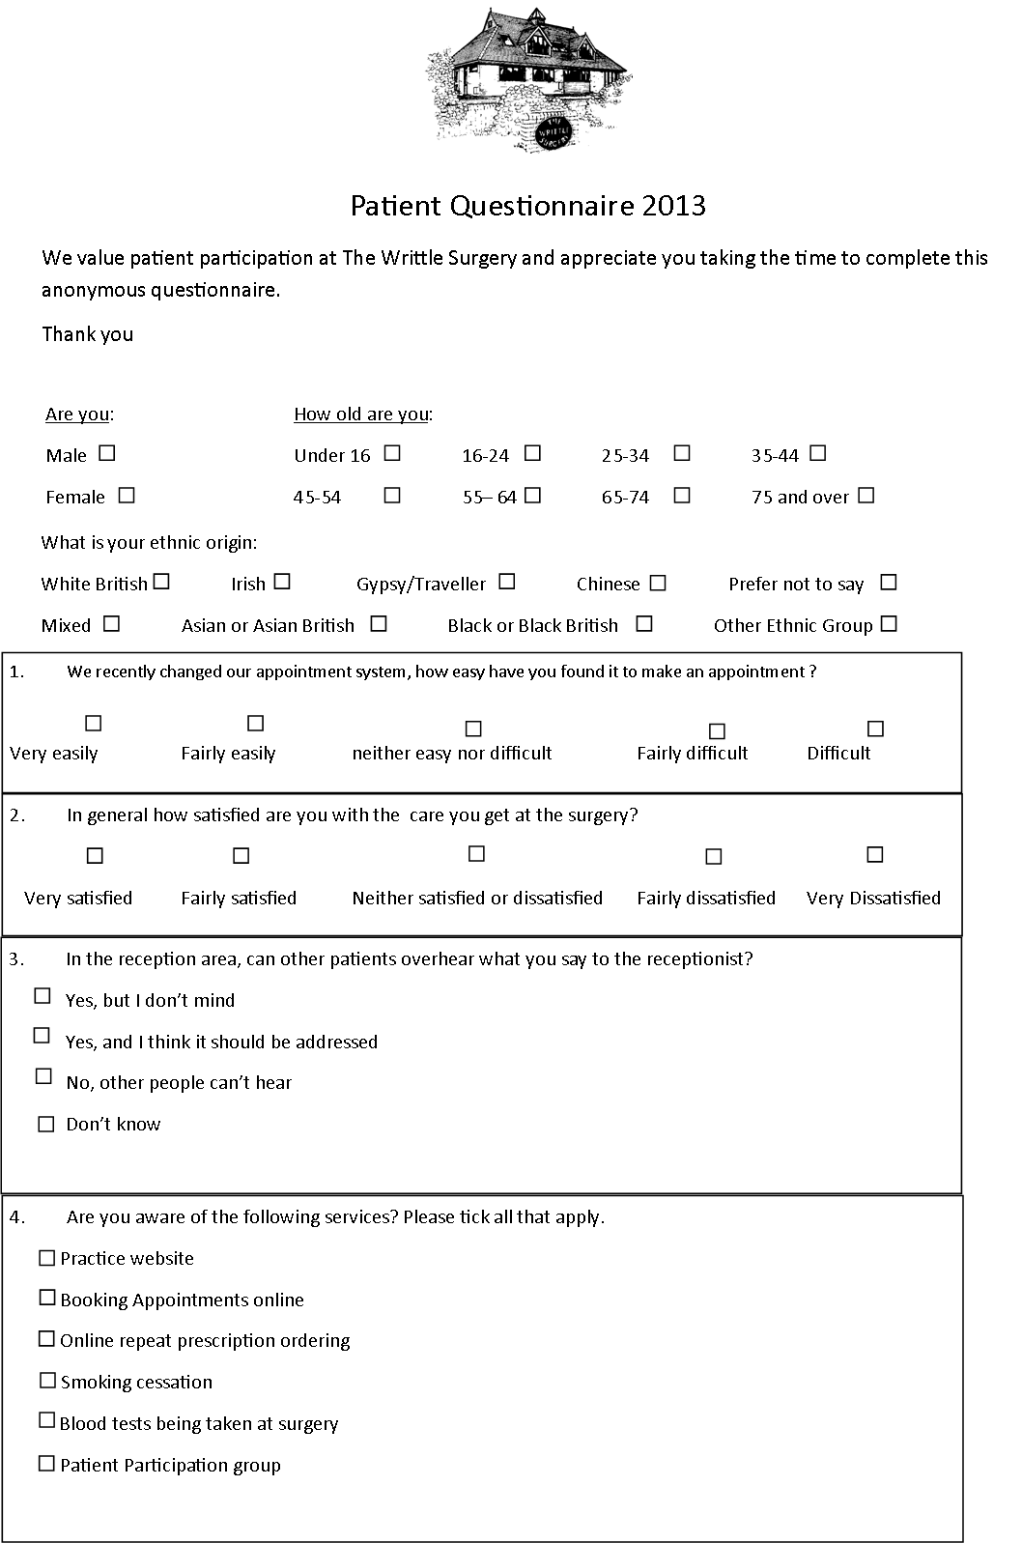

Appendix 2

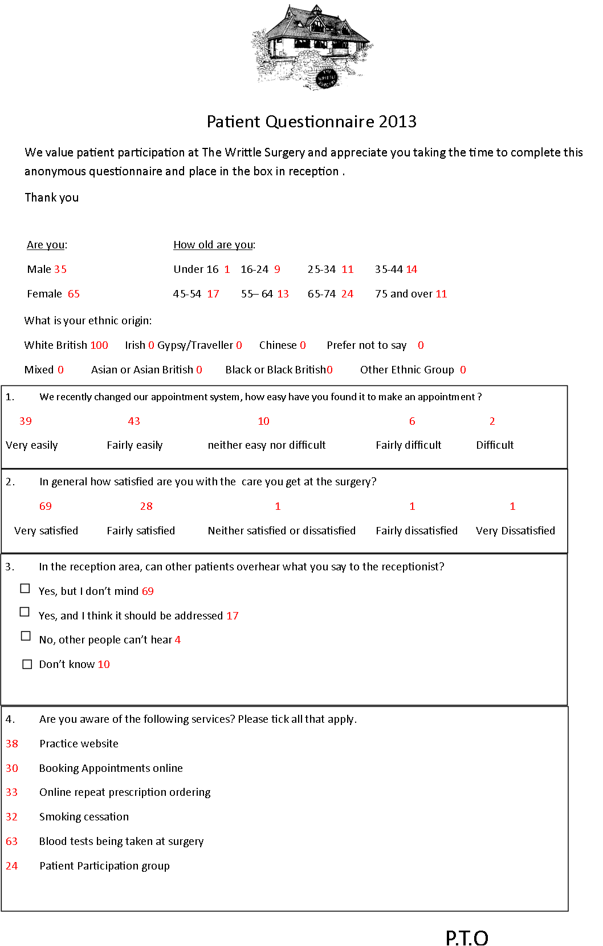

Appendix 3

Meeting to discuss survey results

**Writtle Patient Group (WPG) AGM**

**Meeting held at Writtle Parish Rooms on Thursday 7th November 2013 at 7.p.m.**

Attendees: Dianne Collins, Stuart Rawlins, Christa Bringloe, Bernard Bridges, Phil Nunn, Michael Heard, Seewleen Walker

Apologies: Margeret Loster, Gordon Ingram Rachel Maddock .

1. Minutes from the last meeting held 5th September 2013 were agreed.

Matters Arising from the minutes:-

2. Admin Group met with Rachel at the surgery on 26th September at 10 a.m. Dr Vincent had agreed to lend the group his medical skeleton for the Christmas Tree Festival and the surgery were giving us various bandages empty pill bottles etc to use to decorate the tree

1. Publicity Group suggested that we should begin to advertise in Writtle News

1. Treasurers Report. Phil Nunn reported that with no activity on the account.

1. Website. As Gordon was not present there was no report regarding the website.
2. Surgery News. It was noted that the surgery in its news letter were advertising the Diabetes Health meeting. The surgery had sent us the results from the questionnaire that they had carried out in October. The main area of focus was whether the reception area needed changing, the waiting room is not a very ‘confidential area’ and so the question was raised regarding this (see results) it was decided by the surgery and the PPG that patients did not mind that sometimes they are over heard and there was no change to implement although they are to publicise that patients can have hidden conversations if they wish. The surgery also wanted to look at the services they offer and how whether people are aware of them. It was felt that all the areas on the survey could be looked at including improving how patients find out what the nurses can see. Publicity of online appointments and online repeat prescriptions was to be the main focus of the surgery, as well as the publicity of the PPG!
3. Christmas tree Festival. Christa was to organise it with the youngsters from Hylands being encouraged to be involved as a project. Christa was thanked for all the hard work she had put into getting the pupils from Hylands 6th Form involved in the Tree Festival.
4. Any Other Business. A meeting was agreed for 5th December to update everyone on the Diabetes evening.

**The next full meeting of the committee was scheduled for 13th February 2014 to be held at the Surgery at 7.p.m**.



Appendix 4

The Writtle Surgery

Patient participation group survey results and action plan 2013/2014

Introduction

We based some of the questions on the previous years questionnaire so that there would be some comparison in results. This year however we created a more specific short questionnaire to encourage patients to complete it, including the issues the PPG felt were most important.

The survey took place week commencing 14th October 2013 during this time patients were asked to complete them, we did not ask patients to take the questionnaires away as we felt this would reduce the rate of responses. We received 100 completed surveys.

Key statistics

* 100% of people who completed the survey were white British, this was a disappointing figure as even though we tried to target patients in waiting room and consulting room only white British people completed the survey. We have a broad range of patients who visit the surgery and receptionists and GPs did actively encourage patients to complete the questionnaire.
* 69% of people were very satisfied in their care at the surgery
* Only 30 of people were aware that appointments could be booked online
* 63 people knew that blood tests could be taken at the surgery

Areas for improvement

* 69% of people surveys said that although they can sometimes be overheard in the waiting room, they did not mind
* We were pleased to see an improvement, that 43% of people found it ‘fairly easy’ to book an appointment that is compared to 39% in 2012/2013, and 53% in 2011/2012. We have recently changed our appointment system and are pleased to see it working as there is a slight improvement in peoples opinions from previous year
* The free text comment section of the survey was the most interesting as patients were able to comment on the issues important to them
  + - Appointments
    - Opening Hours
    - Waiting Room

Appointments

We were pleased to see an increase in the amount of people who found it ‘fairly easy’ to get an appointment at the surgery, compared to the last year.

The PPG is a good forum to discuss any changes we are looking to make regarding the appointment system, the PPG were instrumental in making the new appointment system a success.

The surgery has taken part in the primary care foundation toolkit which highlighted areas of improvement. And we are still working on this, with a change in our nursing staff we are going to increase the amount of ‘book on the day’ appointments for the nurses and also publicise more widely what our practice nurses can see, in order to free up GP appointments.

Action plan

* Patient education through PPG of booking appointments
* Publicise the availability of booking appointments online
* Publicise the new increase of nurse book on the day appointments
* Publicise what practice nurses can treat

Patient participation group

Are you aware of the patient participation group?

This was a disappointing result as the PPG have worked to campaign and raise their profile within Writtle. They are working on their own website. They also have posters around the village and in the surgery. They also have a full set of events in2014 having held their first event a diabetes evening in the village hall. They had guest speaks from broomfield and a nurse and GP from the surgery to give a talk. It was well attended and they have planned many more around different topics.

Action plan

* Publicise the PPG in and around the village
* Use the PPG events to raise their profile

Opening hours

We had a number of comments in the free text section about opening hours. (Appendix 1)

Our surgery is open 08:00-18:30 daily. We would not want to increase these hours due to cost, staff pressures and capacity.

Many patients commented they would like weekend opening hours. Unfortunately the surgery used to open on a Saturday morning for commuters and workers, however more often than not it was retired patients who booked the surgeries, therefore not fulfilling its purpose.

We do however offer flu clinics on a Saturday.

Action Plan

* Publicise new appointment system and change in nurses clinics
* Unlikely to increase opening hours, but we are looking into access eg more phone triage.

Waiting Room

Again In the free text section of the survey patients wrote a number of comments about the waiting room. The main observations listed below,

* Children’s area
* Lack of privacy
* Temperature

It is understandable that patients get frustrated when they are unwell and are faced with a full waiting room of patients.

We do feel that since the last survey the situation in the waiting room has improved, patients used to arrive at 10.30am for a ‘walk in’ clinic. It was at that time that the waiting room became overcrowded and hot.

We have turned the radiators down in the waiting room and the receptionists are conscious of the temperature and will often open the window.

A few patients have commented on having a children’s area, this is something that we are looking at investing in however it would be difficult as we have a very small waiting room. It is off putting for patients and staff when children are running around and making noise.

It is interesting that 69 people said they did not mind being over heard in the waiting room. But some people said they did not like the lack of privacy.

It is unfortunate that patients are able to hear each other, we do have the radio one to try and distract people. We would be unable to alter the current waiting room situation however we do have a hidden area where receptionists are able to have private conversations with patients.

If patients wish to speak to the practice manager privately they can do so in her office.

Action Plan

* To ensure receptionists are aware that patients may want privacy for some conversations

Conclusion

To put all plans in place in time for the survey to be repeated in 12 months time

Free text comments from patient survey

Opening Hours

* Saturdays
* Open later on some days for people who commute to work
* Add Saturday morning emergency surgery
* Weekends
* 8.00am-20.00pm
* definitely need available appointments in the evening (til 9.30pm) and weekends, perhaps even avoid booking OAP's atc at these times- this is prime commuter territory and very difficult for people working in London with current system- especially if something felt non urgent.
* as early as possible
* longer hours perhaps sat mornings

Waiting room

* books would help
* Separate from reception
* Chairs to be more comfortable
* More child friendly
* Too hot and busy at times, no privacy
* Clock on wall
* Waiting room is not very inviting
* Check in monitor should not be in view of other patients in the waiting room
* Tea and coffee machine
* something to read whilst waiting
* bigger
* not very inviting
* a bead thing for children to play with

Parking

* car park can be a problem also pulling out is dangerous, could improve line of sight by banning parking in the laybys
* bigger car park
* have an in and out to car park

General

* frustrating not to be able to access dispensary at times during surgery opening hours
* allow all patients to use the dispensary

Appointments

* only always one receptionist- always busy
* can be difficult getting through on phone to make an appointment
* I think if you ring on the day you should be seen
* being able to book in advance and not having to wait for the day to phone as not always easy when working
* longer time of appointments, shorter time to wait to have booked appointment, book 4/52 in advance
* phoning the surgery in the morning can be very difficult- no call back facility but availability of appointments has improved
* bring back pm appointments booked at 2pm

Other comments

* We had excellent service from Jackie Brunning today, who, in addition to giving our flu jabs, gave us very knowledgeable and helpful information re travel vaccines.
* always pleased with everything
* I have no complaints I think the surgery works very well, will look into online appointments now
* clearer instructions about travel vaccination appointment, I was not told I had to contact the surgery

**Appendix 4**

**Writtle Patients Group Chair’s Report**

**March 2013**

This is the first AGM following the starting up of the patients group in March last year.

I became the Chair in September last year. Mary Power had been elected as the chair in May 2012, but had to give up the post for personal reasons and as I was the Deputy Chair I took over.

Stuart Rawlins stepped up as Deputy Chair. He with a small group had been instrumental last March in getting the fledgling group off the drawing board he is a great help in making sure that we are doing everything in the right way. Your contribution Stuart has been invaluable and I hope it will continue.

We are here to be a critical friend to the surgery. Under the new Healthwatch which comes into being replacing The Link along with the changes to the NHS in April every surgery should have a patient participation group.

We are fortunate in having Catriona Hoffman as our hardworking secretary. Passing out information received, booking meetings and getting out minutes etc.

Money was an issue to begin with as well as the need to have a treasurer a publicity officer and fund raiser. We were in a catch twenty two position. Apply to X for money, but in order to be able to do this we needed to have a bank account and a treasurer. We wanted to have website links, but this costs money.

Thankfully this has now been resolved satisfactorily. The practice has given us a small amount of money to help us get started for.

Gordon Ingram has taken on the role of getting the website up and running for the patients group.

Phil Nunn has agreed to be our treasurer and has arranged for us to have a bank account at the Co-operative Bank

Michael Heard has taken on the role of fund raiser and has some very good ideas in the pipeline for raising funds.

The doctors and surgery staff also deserve a vote of thanks for participating in our meetings and keeping us up to date with surgery changes. We are very grateful to you for giving up your valuable time to attend our meetings

Thank you to everyone else who has served this year on the committee. It has taken us nearly a year to get organised. But we now have firm foundations on which to build.

We hope to have an email group established to canvas the views of the patients of the surgery very soon.

If you know of anyone who would be interested in being part of the email group or in serving on the committee, particularly younger people so that we properly represent the surgery population let anyone of the committee know so they can be invited to attend our next meeting.

Appendix 5



Appendix 6

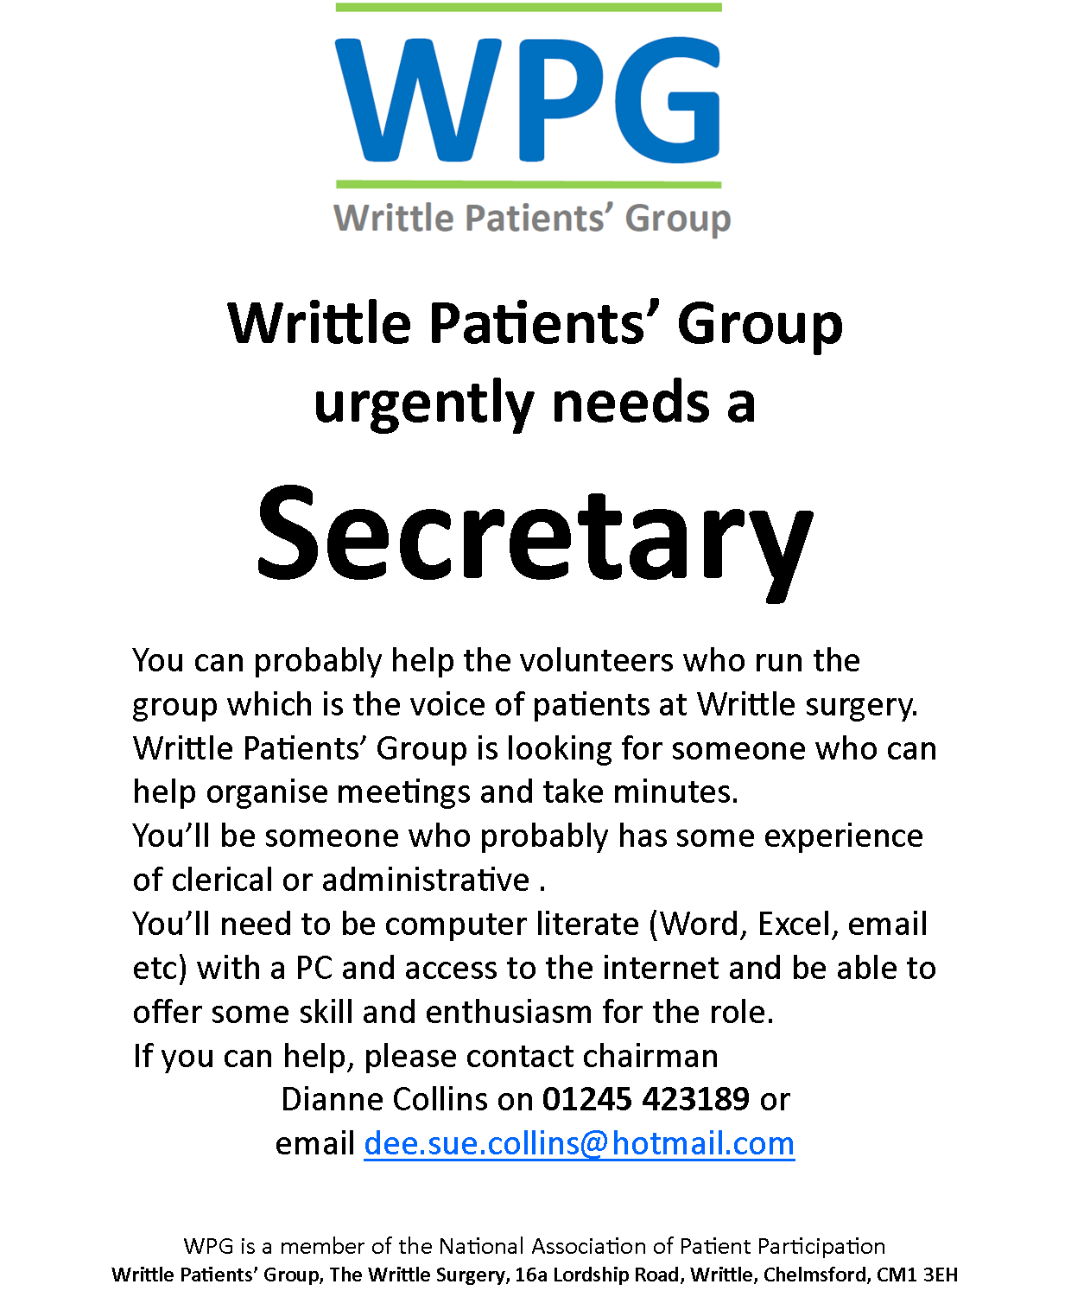

Appendix 7

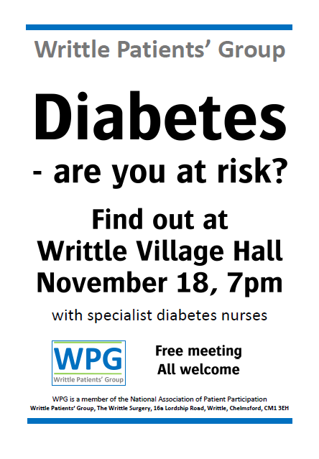

Other meeting minutes

**Writtle Patients Group (WPG)**

**Agenda for meeting to be held at the Parish Rooms on Thursday 5th September 2013 at 7 pm**

Apologies :

1. Welcome & introduction of new members
2. Admin Group Report
3. Publicity Group Report
4. Treasurer’s Report
5. Website Update
6. Surgery News
7. Christmas Tree Festival
8. Christmas Prize Draw
9. AOB

**Writtle Patient Group (WPG) AGM**

**Meeting held at Writtle Parish Rooms on Thursday 5th September 2013 at 7.p.m.**

Attendees: Dianne Collins, Stuart Rawlins, Christa Bringloe, Bernard Bridges, Phil Nunn, Michael Heard, Seewleen Walker

Apologies: Margeret Loster, Gordon Ingram Rachel Maddock and surgery staff.

1. Minutes from the last meeting held 4th July 2013 were agreed.

Matters Arising from the minutes:-

Item 6 from the previous minutes Christa reported that the response from Hylands had been positive with an initiative to have sixth form pupils involved in seeing what goes on at the surgery then a visit to Oxney House to understand sheltered accommodation with a further meeting to understand the role of the pharmacy.

It was suggested that we should notify NAPPs of this initiative as they are keen to report on the activities of the various patient groups.

It was also suggested that the self help information available from the surgery be put on the website.

2. Admin Group had not met since the last meeting. A meeting was arranged for 16th September with Rachel at the surgery. (Please note since the meeting this meeting with the surgery has had to be re arranged for 26th September at 10 a.m.)

1. Publicity Group had not met since the last meeting but will report back at the next

meeting as it plans to meet on 23rd September at 7.p.m.

1. Treasurers Report. Phil Nunn reported that with no activity on the account the balance remains at £581

1. Website. As Gordon was not present there was no report regarding the website.
2. Surgery News. Because of staff sickness and other absences there was no one from the surgery there to update us.
3. Christmas tree Festival. Christa was to organise it with the youngsters from Hylands being encouraged to be involved as a project.
4. Christmas Prize Draw. After a discussion it was decided to abandon a Christmas draw in favour of an health educational event on 18th November in the evening.
5. Any Other Business

It was suggested that we may be able to get money from the Essex Community Fund for a Flyer to be sent out approximately three times a year.

Phil Nunn offered to identify available funding from all sources.

Recruiting was still an issue and everyone was invited to bring along anyone who they met who would like to become involved. Meeting are alternating between day and evening to hopefully cast the net wider.

Date of next meeting 7th November at 1 p.m. in the afternoon.

The Writtle Patients Group

**Constitution**

**Name** The name of the group shall be Writtle Patients Group.

The group shall be affiliated to the National Association for Patient Participation (N.A.P.P Reg Charity No 292157

**Membership** Membership shall be free and open to all registered patients and staff of the Practice..

**Objectives** The Patients’ Group is established to promote health by fostering the highest standards of primary care through patient participation

**Aims** Members of the Group should act as a communication channel between the Practice and the community to help the Practice to implement policies influenced by representative patient views.

The Group should have a role in assisting in the assessment of community ‘needs’ and in respect of this the Group may from time to time conduct surveys in conjunction with the Practice to assist the Practice in improving services.

The Group shall set up an email group to canvass opinions of the members and to allow members of the email group to contact the Patients’ Group with their views on health related matters.

**Powers** The Group shall have the option to raise funds for any or all of the above aims.

The Executive Committee shall not undertake any substantial permanent trading activities and shall conform to any relevant requirements of the law.

A Small Lotteries Licence shall be obtained and renewed annually to enable funds to be raised by way of occasional raffles. Whoever is the Chair of the group will be the promoter of these raffles. The proceeds of which must be used for the furtherance of the aims and objectives of the Group.

**Honorary Officers**

At the Annual General Meeting the members of the group present shall elect from amongst their number a chairperson, a deputy chairperson, a secretary and a treasurer who shall hold office from the conclusion of the meeting. If there is more than one nomination for any of the posts then a ballot should be held for each post that has more than one nomination.

**Executive Committee**

The Executive Committee shall consist of the honorary officers named in the preceding clause and up to fifteen other Members.

Should any member of the committee resign during the year of their appointment the remaining members of the committee may co-opt an eligible person to serve on the committee until the next Annual General Meeting.

A doctor, the practice manager or a representative of the surgery staff nominated by the practice has the right to represent the practice at the committee meetings in an ex-officio capacity.

All members of the Executive Committee may retire from office at the end of the annual general meeting next after the date they came into office but they may be re-elected or re-appointed.

**Eligibility of Membership of the Executive Committee**

No member can be appointed to the Executive Committee who is under the age of sixteen years.

A member of the Executive Committee shall cease to hold office if he or she:

Is disqualified from acting as a member of the Executive Committee by virtue of section 72 of the Charities Act 1993 (or any statutory enactment or modification of that provision);

Becomes incapable by reason of mental disorder, illness, or injury of managing and administering his or her own affairs:

Becomes bankrupt, is disqualified from being a company director or is found guilty of fraud in either the Magistrates or the Crown Court.

**Meetings of the Executive Committee**

At least four meetings excluding the Annual General Meeting shall be held each year.

The meetings shall be chaired by the chairperson and in their absence the deputy chair. Should both the chairperson and the deputy chairperson be absent then the secretary will control the proceedings.

All matters discussed at the meetings shall be put to a vote if a decision is required. In the event of a tied the vote whoever is chairing the meeting has the casting vote.

**Finance**

All funds raised or given to the group shall be held in a bank account set up by the treasurer in the name of the Writtle Patients Group.

There will at all times be at least two signatories to the account.

The accounts of the group will be presented to the Annual general Meeting with an ongoing update presented at each committee meeting.

Funds raised or donated shall be used to pay any legitimately incurred expenses and for the furtherance of the group and the practice.

**The Annual General Meeting**

An Annual General meeting shall be held each year and details of the meeting shall be broadcast via the Surgery notice board, parish notice boards, the internet and word of mouth.

Any item for the agenda of the Annual General meeting should be communicated to the secretary no later than four weeks before the date of the meeting.

Notice of the meeting shall be distributed twenty one days before the date of the meeting along with the name and contact details of the secretary.

**Election and Retirement of Committee Members**

All Officers and Committee members may offer themselves for re-election annually at the Annual General Meeting. If there is more than one nomination for any of the posts then a vote must take place. In the event of a tie then the Chairperson has the casting vote.

**Reports and Accounts**

At the Annual General Meeting reports will be presented of all the activities that have taken place during the year. The accounts will also be presented showing the position to the end of the financial year.

**Constitution**

Any member of the Writtle Patients Group is entitled upon request to a copy of this Constitution.

**Alteration to the Constitution**

This Constitution may be rescinded or amended or waived by a resolution passed at an AGM or a Special meeting of which at least three weeks notice has been given to members. To enact a change two thirds of the members present at either the Annual General Meeting or the Special meeting must vote in favour of the resolution.

**Dissolution**

If the group is wound up or dissolved any monies held by the group at the date of its dissolution shall either be transferred to the National Association for Patient Participation or to a local health based charity as decided by the meeting dissolving the group.

Appendix 8

The Writtle Surgery

**ACTIONS ACHIEVED, HIGHLIGHTED IN RED**

Patient participation group survey results and action plan **2012/13**

Introduction

We based some of the questions on the previous year’s questionnaire so that there would be some comparison in results. This year however we created a more specific short questionnaire to encourage patients to complete it, including the issues the PPG felt were most important.

The survey took place week commencing 24th September during this time patients were asked to complete them, we did not ask patients to take the questionnaires away as we felt this would reduce the rate of responses. We received 100 completed surveys.

Key statistics

* 94% of people who completed the survey were white British
* We had a good split of male to females completing the survey, 41% male and 59% female
* Only 1% said they found it ‘difficult’ to book an appointment at the surgery, which we found positive
* Of the 39 people who were able to collect their prescriptions from the surgery, 11% decided to go elsewhere to collect
* 64% thought it would be a good idea for the surgery to have the facility to make card payments
  + - Install a card machine and till A TILL WAS INSTALLED AT THE SURGERY IN MAY 2013 AFTER CONSULTATION WITH THE PPG. WE HAVE RECEIVED POSITIVE FEEDBACK FROM PATIENTS.

Areas for improvement

* 39% found is ‘fairly easy’ to book an appointment with the surgery, unfortunately that is down from 53% last year
* The free text comment section of the survey was the most interesting as patients were able to comment on the issues important to them (we have focussed on these five areas in the action plan)
  + - Appointments
    - Dispensary
    - Opening Hours
    - Waiting Room
    - Parking

Installation of a card machine

64% of patients thought it would be a good idea to have a card machine installed in the surgery to enable card payments, mainly at dispensary but also for jabs and medicals.

This had been an area that the PPG were extremely interested in setting up, as we felt it would be easier for patients. So we were very pleased with the result of this question.

Action plan

* In line with the new dispensary extension opening we will be installing a card machine and till MACHINE INSTALLED MAY 2013
* This will enable patients to pay for a number of services throughout the surgery by card.

Appointments

Unfortunately it is disappointing that we saw a reduction in the amount of people who found it easy to book an appointment, we hope with the changes we will make in this coming year that next year there will be an improvement.

We have discussed with the PPG about changing the appointment system. The current appointment system is historic and has not changed even through patient demand has increased significantly.

The surgery has taken part in the primary care foundation toolkit (awaiting results) which will highlight areas of improvement.

Action plan

* Patient education through PPG of booking appointments THE PPG ENSURE THEY SPEAK TO PATIENTS ABOUT THE CORRECT USE OF APPOINTMENTS
* Publicise the availability of booking appointments online WE PUBLICISE THIS IN OUR PATIENT LEAFLET, IN THE WAITING ROOM AND ONLINE
* GPs to consider results once published THE GPS USED THE SURVEY RESULTS WHEN CHANGING THE APPOINTMENT SYSTEM IN JULY 2013

Dispensary

Do you use the dispensary to collect your medication (if eligible) ?

There was an option to free text this after a ‘yes or no’ tick box. Of the patients who said no their reasons for not using the dispensary were

* Rather use the local chemist
* Walk past chemist on way home
* Poor customer service
* Chemist

Verbal comments made throughout the year are raley about medication or repeat prescription service which we feel is positive, we would just like all patients who are able to use the service to utilise it.

We will be sending the reception staff and dispensers on customer service training courses in the next year.

We are currently having an extension to the dispensary this should elevate some pressure and waiting time for patients as the space will be increased. There will be a second hatch added, for privacy and also to see more people at once.

Unfortunately by their own admission dispensers are often short with patients, not because they are rude but simple due to time pressures and often a queue at the hatch.

Action plan

* Staff training STAFF HAVE RECEIVED TRAINING IN HANDLING DIFFICULT CUSTOMERS AND IN PATIENT COMPLAINTS OF WHICH ONE AREA FOCUSSED ON CUSTOMER CARE
* Advise patients to raise concerns if not happy WE HAVE OUR COMPLAINTS POLICY ON DISPLAY IN THE WAITING ROOM IT IS ALSO INCLUDED IN THE PATIENT LEAFLET SO PEOPLE KNOW HOW TO RAISE CONCERNS

Opening hours

We had a number of comments in the free text section about opening hours. (appendix 1)

Our surgery is open 08:00-18:30 daily. We would not want to increase these hours due to cost, staff pressures and capacity.

Many patients commented they would like weekend opening hours. Unfortunately the surgery used to open on a Saturday morning for commuters and workers, however more often than not it was retired patients who booked the surgeries, therefore not fulfilling its purpose.

We do however offer flu clinics on a Saturday.

A number of patients also commented on late night opening would be preferable, we do in fact open early on a Friday morning for extra appointments and late on a Monday evening, until 20:00.

Action Plan

* Publicise late night and early morning openings PUBLISICIED ON WEBISTE, NHS CHOICES AND IN WAITING ROOM
* Unlikely to increase opening hours, but we are looking into access eg more phone triage. IN JULY 2013 THE NEW APPOINTMENT SYSTEM WAS INTRODUCED AND PATIENTS CAN NOW SPEAK DIRECTLY TO THE ON CALL DOCTOR ON THE PHONE, WHO CAN ASSESS IF THE PATIENT NEEDS TO COME TO THE SURGERY

Waiting Room

Again In the free text section of the survey patients wrote a number of comments about the waiting room. The main observations listed below,

* Kids area
* Temperature
* More seats
* Magazines

It is understandable that patients get frustrated when they are unwell and are faced with a full waiting room.

Unfortunately our waiting room is rather small and when the ‘extras’ surgery begins at 10.30am it often becomes very overcrowded with patients having to stand due to lack of seating. Unfortunately we are at full capacity for seating in the waiting room.

The heating in the building is controlled by one thermostat so again when the waiting room becomes full patients often say it is too hot, but the staff upstairs would say it is too cold!

Two people commented on having a water machine, unfortunately again this would be an unnecessary cost and wastage, it would also be at children’s height for them to touch which would be dangerous. If however a patient would like a glass of water when in the waiting room, they only need ask reception who would fetch one.

Many commented on the wish for magazines, the magazines and rack were removed when the risk on swine flu was great. And we did not want to spread infection in the waiting room.

However this is something we are looking into reinstating, as we like to try and keep patients happy, also due to having such a small waiting room patients are able to hear receptionists on the phone. If people are reading it may cut down on how much they are listening to reception.

Action plan

* The 10.30 am ‘extras’ list will be removed when the new appointment system starts, this should mean a steady flow of patients and therefore the waiting room may not be so crowded. THE WAITING ROOM HAS BECOME MORE STAGGERED THROUGHOUT THE DAY AND SO PATIENTS ARE FINDING IT MORE PLEASANT

Parking

Of the free text comments many were about parking at the surgery, many commented on the lack of a disabled bay.

Many of the comments were about the amount of parking spaces. Unfortunately at 10.30am when our ‘extras’ clinic begins the car park becomes very full.

This also causes a safety issue as Doctors are often blocked in, when they may need to leave the building due to an urgent visit.

There is no where we would be able to increase the parking space unfortunately. We have an unmarked staff parking area as a large number of our staff drive, however patients do not often take as much care as they should and there are often incidents in the car park.

For disabled patients, there is a large drop of space at the front of the surgery next to the disabled ramp. There is also a long layby outside the surgery onto the pavement if you need more access to the back for example to unload a wheelchair.

Action plan

* Through PPG educate patients about parking and the lack of space and to take care when parking WE ARE CAMPAIGNING WITH ESSEX POLICE AND HIGHWAYS AGENCY, WITH HELP FROM PPG REGARDING THE LACK OF PARKING IN LAYBY ADJACENT TO SURGERY
* Ensure staff park closely and to not block doctors in. STAFF PARK AS BEST THEY CAN AND TRY TO ENSURE DOCTORS CAN GET OUT IN CASE OF EMERGENCY

Conclusion

To put all plans In place in time for the survey to be repeated in 12months time