The Writtle Surgery team
Practice Manager: Karen Hepworth
Practice Nurses: Christine Hart, Jess Brown, Katie Gutteridge and Melissa Gardner. Our Practice Nurses are all RGN and specially trained for General Practice. They can advise on many minor problems and also run specific clinics for: diabetes, heart disease, asthma, im- munisations, cervical smears, smoking cessation and NHS

Dementia Friendly
We are a dementia friendly Practice.

NHS Mid Essex ICB
NHS Mid Essex, Swift House, Hedgerows Business Park, Colchester Road, Chelmsford, Essex CM2 5PF. 01245 398770

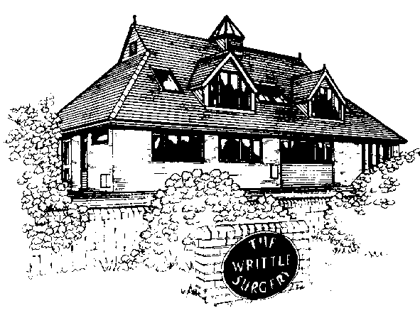
The Writtle Surgery

The Writtle Surgery
Updated Au-
gust
2024

health checks. Supported by Health Care Assistant

Hollie Smith .
Practice Administrator: Julie Robinson, Gayle Payne, and
Sian Boyce
Medical records and administration: Jo Willsher and Jen Wright
Secretaries: Jinnie Woodgate and Wendy Nicholls Receptionists: Julie Bigsby, Gail Rogers, and Aerona Browne . Our receptionists are all trained and here to help you.
Dispensers: Sarah Spooner, Jo Hudson, Summer Hooton and Katie Healy. Our dispensers are fully qualified to pre- pare and dispense prescriptions and to assist with que- ries about your medication.
Practice Based Pharmacist: Viviyana will be dealing with long term conditions and medication reviews.
Community Nurses: If you need a nurse to visit you after coming out of hospital, this will normally be arranged by the hospital; in all other circumstances please contact our receptionist who will contact the nurse for you.
Health Visitor: Her main responsibility is with the under 5 year olds.

Complaints or comments about our service
If you wish to make a complaint or comment then please contact the practice manager, Karen Hepworth either in writing or by telephone. We will endeavour to resolve your complaint within two weeks.

Writtle Surgery Services
Services provided at The Writtle Surgery include: core GP work, monitoring INR patients, on-site ECG, phle- botomy, 24 hour blood pressure monitoring, long term disease management clinics for asthma, diabe- tes, COPD, hypertension, vascular disease including coronary artery disease and stroke, chronic kidney disease, minor surgery, family planning services in- cluding contraception implants and coils, smoking cessation, childhood immunisations, travel clinic , health checks including new patient checks and cholesterol testing.

Your responsibility to us as a patient
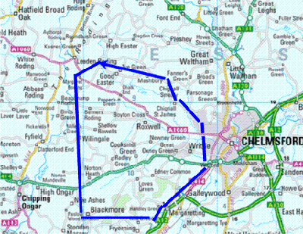
Ask a team member caring for you to explain further if there is anything you don't understand and/or are worried about. Treat other patients and staff with po- liteness and consideration, recognise that racial, sexu- al or other harassment of staff, other patients or visi- tors is not acceptable,. Attend your appointments on time or contact us in advance if you are unable to make them.
We operate a ‘zero tolerance’ policy, which means any form of verbal or physi- cal abuse including homophobia, biphobia and transphobia. Whether aimed at or conducted by either patients or staff will be reported to the police.

16A, Lordship Road, Writtle, Chelmsford CM1 3EH
www.writtle.gpsurgery.net
Visit our website for more information
Tel: 01245 421205

The surgery is open 8:00am -18:30pm Monday to Friday. We offer extended hours on Monday and Wednesday evenings and Saturday’s through PCN and these are pre-bookable only.

Outside of these hours and on bank holidays please call
‘111’ for advice or if an emergency call 999.
Partners
Dr Ramkumar Kumarakulasingham MB CHB Aberdeen 2003 MRCGP Dr Beate Clouth State Exam Medicine Germany 1996, MRCS 2004 & MRCGP 2014
Salaried GPs
Dr Reena Sodha MB BS London 2006 BSc MSc DRCOG MRCGP DFSRH
Dr Alexander Bradford MBBS & MRCGP
Dr Elena Savaci MRCGP

Writtle Surgery Practice area.

Please check the website to see if you live in our area.

Your Medical Records
These are accessed only when necessary and are ac- cessible by all staff members. They are treated as high- ly confidential. These can be accessed via your NHS App..

Appointments
Appointments can be booked over the phone, online on the NHS APP or in the surgery. Please telephone 01245 421205 between 08:00am– 18:30pm or ask at reception. If you feel you need to see a Doctor on
the same day then please call as early as you can and if you feel your problem is urgent then please tell reception. We will ask the nature of your problem in order for you to receive the most appropriate help. If you wish to see a particular GP you may have to wait a few days.

Online Services (Booking appointments and repeat prescriptions)
You can book appointments, view a brief summary of your record and request repeat prescriptions online. Please call or pop into the surgery to set this up.

Home Visit Requests
If you are unable to attend the surgery because of your medical condition and wish the doctor to visit, please telephone before 10.30am. The doctors can then plan their visits. We are always happy to give advice over the telephone if you are unsure whether a visit is necessary.

Telephone Consultations
You may request a call back from a GP if you feel your problem could be dealt with without a visit to the surgery. The Doctor may still ask you to attend the surgery if they wish to see you.

New Patients

All patients wishing to join the Writtle Surgery should come into reception. The Practice covers an agreed area and we accept patients who live within the area. We request all new patients to have a
simple medical check with a nurse, where you will be required to bring a urine sample. If you have any repeat medication please bring a copy of your prescription with you.

Test Results
If you require test results please check online on your NHS APP or telephone 01245 421205.

The Surgery dispensary
If you live more than a mile as the crow flies from a pharmacy you may be able to obtain medicines prescribed by your doctor from the surgery dispensary.
You will be informed if this applies to you when you register. The dispensary is open 8.30am-6.30pm daily. Receptionists cannot give out prescriptions during this time. If you require medication urgently please see reception.

Repeat Prescriptions
Please return repeat prescription request slips by hand online, through the NHS App or post to: “Prescription Box” at the Writtle Surgery and allow two working days before collecting your prescription. If you include a stamped addressed envelope we will post them on to you. If you are on regular medication please order only once a month.

Child Immunisations
These are administered in the nurses’ morning clinics. You will receive a letter when your child is due an immunisation. Please contact reception to book an appointment. We do not administer childhood immunisations on a Friday.

Outside Surgery Hours
If you are feeling unwell you can check your symptoms on the NHS app. You can also call this 111 if you have a non-urgent medical query or would like more information about a health related issue.

If you feel that you need to see a doctor urgently outside of normal surgery hours then please phone NHS 111 they operate 24/7.

Please do not go to A&E unless you have a life threatening condition such as chest pain or severe difficulty breathing then please telephone 999.

Cervical Smears tests
You should receive a letter from the Health Authority inviting you for a test which our nurses perform.

Statement of fitness for work certificate You do not require a doctor’s certificate for any illness lasting less than six days. Your employer may require you to complete a “self-certificate” which is available from your employer or online.

Contraception
We offer coils and implants to our patients . Please speak to reception for more information.

Mammography Service
The Health Authority invite women from 50 to 64 years of age (and over if you request). If you are over 50 and have not been screened in the last 3 years please telephone 01206 744749.

Minor surgery
We offer joint injections. - please speak to reception for more information.

Foreign Travel
Please ask at the reception. We will ask you to complete a pre-travel questionnaire.

Named GP
All patients are registered to ‘The Writtle Surgery’ however you have a ‘named’ GP who will oversee your care although it is your choice
which doctor you see.

Non NHS Services
Fees are charged for non NHS services such as insurance reports, holiday cancellation forms, PSV, taxi medicals and fitness to travel. Please ask at reception for fees .

Confidentiality
All employees working in the NHS are bound by a legal duty of confidence to protect personal information they may come into contact with during the course of their work. This is not just a requirement of their contractual responsibilities but also a requirement within the Common Law Duty of Confidentiality and General Data Protection Regulation 2018 (GDPR). It is also a requirement within the NHS Care Record Guarantee, produced to assure patients regarding the use of their information.

