Dr Ramkumar Kumarakulasingham  GMC: 6071669  Dr Beate Clouth  GMC: 5979449  Dr Emma Mannan  GMC: 7021169  Dr Alexander Bradford  GMC: 6147578  Dr Elena Savici  GMC: 6135705 |    | The Writtle Surgery  16A Lordship Road  Writtle Chelmsford  Essex CM1 3EH  Tel: 01245 421205  Practice Manager:  Karen Hepworth

Welcome to our Patient Newsletter

January 2026



As we begin a new year, we would like to wish all our patients a happy and hopeful 2026. We know that winter can be challenging time, and we want to reassure you that our team is here to support you.

The past year has been a busy one for Writtle Surgery and for our colleagues. By working closely with other local providers, we have continued to adopt services to meet the needs of our community during a period of ongoing NHS pressures.

We would like to thank our patients for your patience, understanding and kindness towards our staff over the past year. Your support makes a real difference.

As we look ahead we remain committed to providing, safe, compassionate care for our community. Please read on for important winter health information and updates about our services

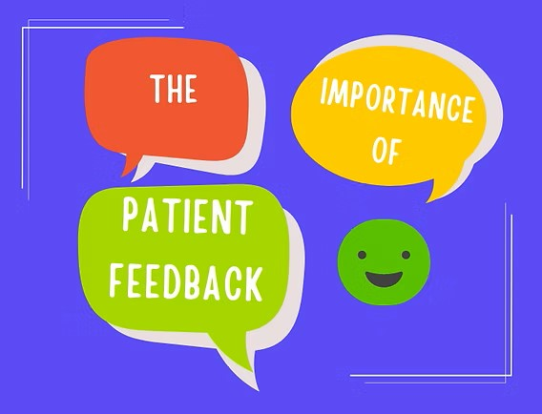 Patient Feedback
We Value Your Voice: Share Your Feedback with Us
At Writtle Surgery, providing the best care possible is at the heart of everything we do. One of the most important ways we can improve is by listening to you, our patients. Your experiences, insights, and suggestions help us understand what’s working well and where we can make positive changes.
Why Your Feedback Matters
Every comment, suggestion, or compliment you share plays a crucial role in shaping our services. Feedback helps us:
- Enhance the quality of care we provide.
- Make our facilities more comfortable and welcoming.
- Ensure our staff have the support and resources they need to serve you better.
- Identify opportunities to introduce new services or improve existing ones.
How You Can Share Your Feedback
We want to make it as easy as possible for you to share your thoughts. You can:
- Complete a short feedback form online via Friends and Family or on Google.
- Speak directly to a member of staff.
- Participate in surveys or patient groups that we run periodically.
Your Voice Makes a Difference
Every piece of feedback we receive is read carefully and used to improve the patient experience. We are committed to acting on your suggestions and celebrating the things we do well.
Thank you for helping us make Writtle Surgery a place where every patient feels heard, valued, and cared for.

Keep warm – Cold weather can affect your health, particularly if you have a long-term condition. Try to keep your home warm and dress appropriately when going outside.

Reduce the spread of infections. Wash your hands regularly, ventilate rooms where possible, and avoid contact with others if you have symptoms such as vomiting or diarrhoea.


Our Commitment to Zero Tolerance
At Writtle Surgery, the safety and well-being of our patients, visitors, and staff is our top priority. We operate a Zero Tolerance policy towards any form of abuse, aggression, or harassment—whether verbal, physical, or online.
This means that any behaviour that threatens, intimidates, or harms our staff or other patients will not be accepted and may result in removal from our premises, and practice list.
We are committed to providing a safe, respectful, and compassionate environment for everyone. Your cooperation helps us ensure that Writtle Surgery remains a place where care and kindness are always at the heart of everything we do.

It’s not too late to get your flu Jab

As the weather is getting colder, we remind you that it is not too late to get your flu jab for this year!. We have appointments available to book into now!

If you believe you are eligible and have not received an invitation, please contact us.

Please support your local NHS by booking with us! Thank you.

 Winter Weather

As we approach the winter months, we would like to remind patients to take extra care when visiting the surgery.

We do our best to grit the car park, but please be aware of slippery conditions, and take extra care when walking into the surgery. Thank you for your caution

Grief and Loss

There is no timescale for how long grief lasts, or for how you should feel at any point during the year. Support is available if you are finding it hard to cope with grief, stress, anxiety or depression. Things you can try with bereavement, grief and loss:

Talk about your feelings with a friend, family member, health professional or counsellor. You can also contact a bereavement support organisation such as Cruse on 0808 808 1677

If you are struggling with sleep, visit the Every Mind Matters website for practical sleep tips. Consider peer support, where people use their own experiences to support each other. Find out more on the Mind website.

Listen to free mental wellbeing audio guides available at nhs.uk

If you need additional support, you can access free NHS talking therapies, such as cognitive behavioural therapy (CBT), you can refer yourself directly without needing a GP referral. For more information please visit nhs.uk

Missed Appointments

Throughout December we had 95 appointments missed without prior cancellation.

If you are unable to attend an appointment, please let us know as early as possible so we can offer the time to another patient.

Welcome Our New Reception Team Members!
We are delighted to announce that our reception team has grown! Please join us in warmly welcoming Tam Scott and Rhia Feltham to our practice.
Tam and Rhia are passionate about ensuring every patient feels valued and supported from the moment they walk through our doors. They are excited to help make appointments, answer questions, and ensure that your visits run smoothly.
Both Tam and Rhia are eager to meet all of our patients and provide the welcoming, efficient service you’ve come to expect. We are thrilled to have them on board and know they will be a wonderful addition to our team.
Next time you visit, don’t hesitate to say hello and give them a warm welcome!

This Photo by Unknown Author is licensed under CC BY
Thank you

Writtle Surgery

